
K&M Tire

Fleet
2/13/2025

Table of Contents
1. K&M Tire 5
2. Truck Purchase Overview 8
3. Truck Purchase Scenario’s 10
3.1 Route Addition 10
3.2 To Determine What Truck is Needed: 10
3.3 Repair Costs > Value of Truck 10
3.4 Forecast for Truck Replacement 11
3.5 Truck Accident 12
3.6 Preparing Retired/ Wrecked Trucks for Resale 12
4. Requesting Truck Quotes 14
4.1 Interstate Truck Source (Hino) 14
4.2 Flag City Mack (Hino) 14
4.3 Selking International (Isuzu) 14
4.4 Rush Truck (Hino) 15
4.5 Crown Motors (Dodge Trucks) 15
5. Proposal to Replace Aged Trucks 16
5.1 Writing a Summary 16
5.2 New Vehicle Purchase 17
5.3 Decals and Placement 18
5.4 Installing/Uninstalling Samsara Gateways 19
6. Truck Warranty 22
6.1 Manufacturers Truck Warranty 22
6.2 Extended Warranty 22
7. Truck Maintenance Approval 23
8. K&M Own Use Tires 24
9. Maintenance Intervals 31
9.1 Why do we look at maintenance intervals. 31
9.2 What are our maintenance intervals. 31
9.3 What are the manufacturers’ maintenance intervals. 31
9.4 When do you calculate the maintenance intervals 31
9.5 Why do you calculate the maintenance intervals. 31
9.6 How do you calculate the maintenance intervals. 32
9.7 Cost per mile. 32
9.8 How do you calculate cost per mile. 32
9.9 Why do you calculate cost per mile. 32
9.10 When is the cost per mile important. 32
10. Fleet Schedule (Manager’s) 33
10.1 Maintenance Schedule 33
10.2 Maintenance Schedule Example 33
10.3 Maintenance Log (Manager’s) 34
11. Estimate Approval / Denial 36
11.1 Estimate Review 36
11.2 Estimate “Approval” 36
11.3 Estimate “Denied” 36
12. Truck Value 38
12.1 Truck Value Spreadsheet (AKA Wrecked Truck Tribune Value) 38
13. Freight Billing 39
14. Firestone (FS) 514349 (BS-FS Tab) 40
14.1 Firestone / Bridgestone Excel Tab 40
14.2 Firestone / Bridgestone MaddenCo 40
14.3 Syncada Firestone / Bridgestone 41
14.4 Syncada Invoice Statement 42
14.5 Syncada Notes 42
15. Continental / General (CO / GE) 1005593 (C – GE Tab) 43
15.1 Continental / General Excel Tab 43
15.2 Firestone / Bridgestone MaddenCo 43
16. Goodyear (GY) 101167 (GY Tab) 45
16.1 Goodyear Excel Tab 45
16.2 Goodyear MaddenCo 45
16.3 Goodyear JDA Website 46
16.4 JDA Website Notes 47
17. Cooper Findlay to Franklin 212660 (Cooper) 48
17.1 Cooper Findlay Excel Tab 48
17.2 Cooper Findlay MaddenCo 48
18. Reviewing Vendor Statements (Monthly) 50
18.1 Vendor Statements 50
19. K&M Forklifts & Squeeze Clamps 51
19.1 Standards on Forklifts / Squeeze Clamps 51
19.2 Forklift/Squeeze Clamp Forecast 51
19.3 Forklift Summary Spreadsheet 53
19.4 Forklift Dealers for Quotes 53
19.5 Forklift Purchase Approval Summary 54
19.6 Forklift Purchase Approval Summary 54
20. Transporting Clamp Trucks at K&M Tire 55
20.1 Approval & Notifications 55
20.2 Steps for Preparation/Transportation: 55
21. Fleet PM Schedule (Manager’s) 60
21.1 Maintenance Schedule 60
21.2 Picker PM Intervals (HUB Warehouses) 60
21.3 Picker PM Intervals (Satellite Warehouses) 60
21.4 Forklifts PM Intervals 60
21.5 Maintenance Log (Manager’s) 60
22. Estimate Approval / Denial 62
22.1 Estimate Review 62
22.2 Estimate “Approval” 62
22.3 Estimate “Denied” 62
23. Picker Warranty 63
23.1 Manufacturers Pickers Warranty 63
24. Selling Company Assets 64
25. Truck Move Approval 65
26. Installing/ Uninstalling Samsara Gateways 66
27. Electric Vehicle- Public Charging 68
27.1 ChargePoint- Account Setup 68
28. Miscellaneous 71
28.1 Code for padlocks on gates 71
Appendix H: Revision History Tracking 74

- List of Tables
Table 1 - Revision History Tracking 59

K&M Tire
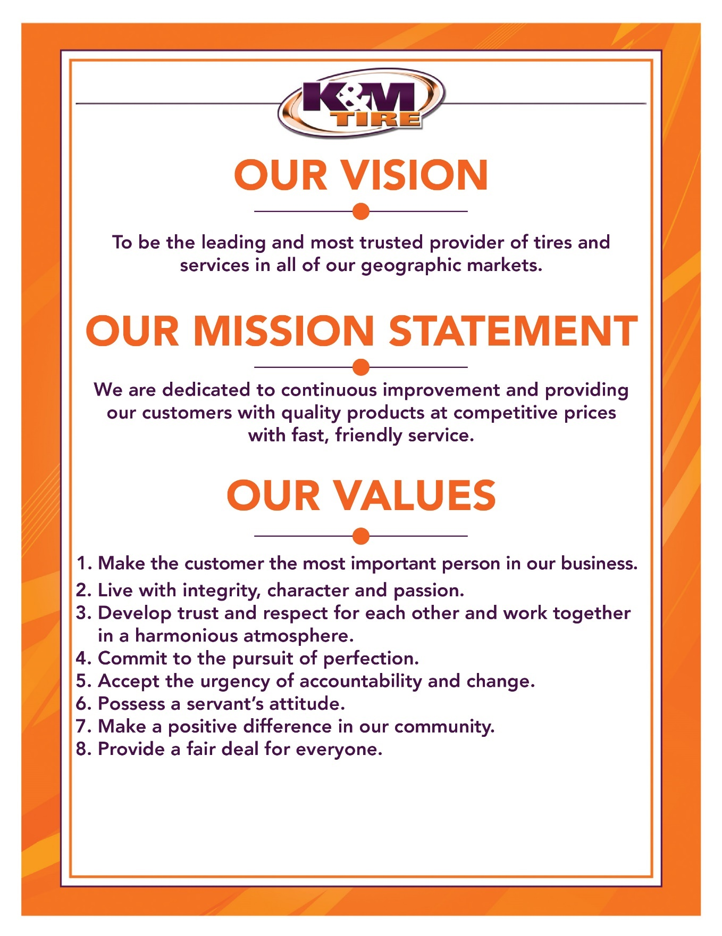

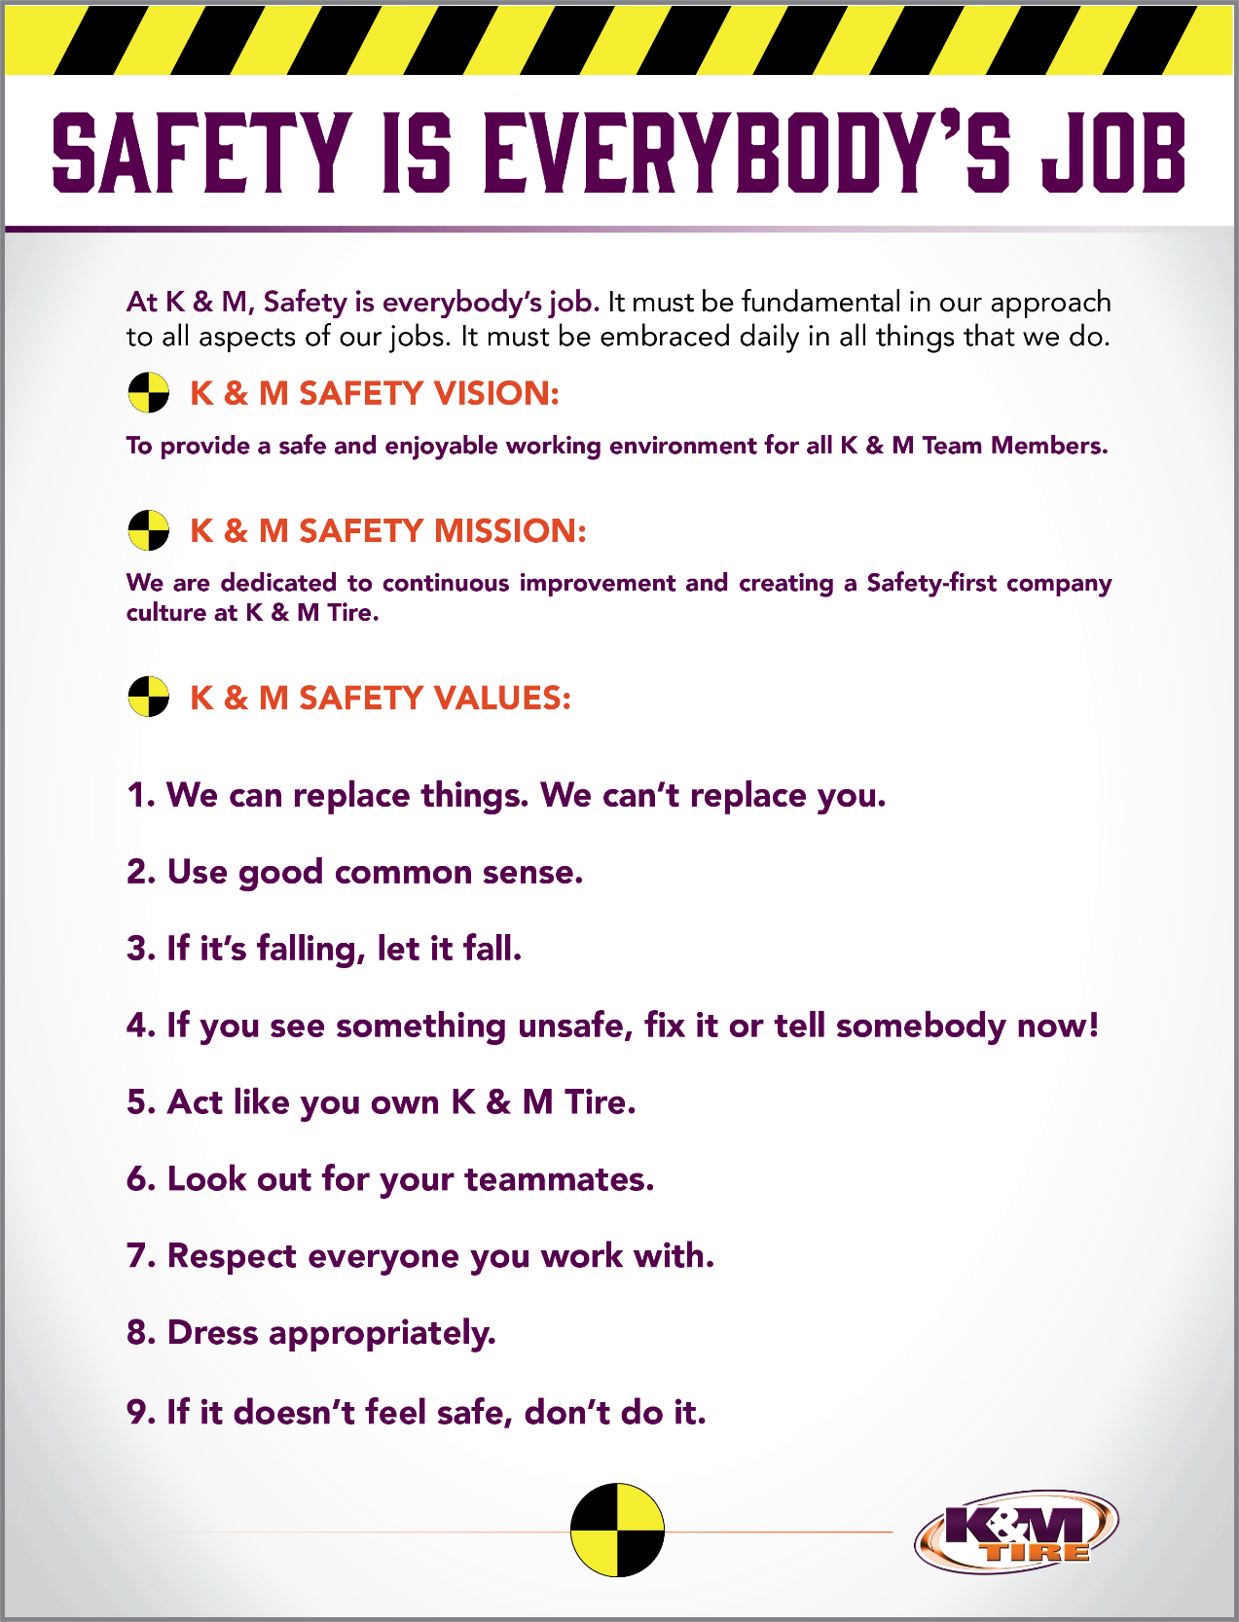

K&M Tire US Footprint
Click on the below link to see the footprint map.
http://kmtire.com/km-cgi/distmap

Truck Purchase Overview
When the need arises for a new truck purchase, a summary is needed as to the reason “Why.” All truck purchases need to be justified and make good business sense.

  - Identifying the need for a new truck-there are multiple reasons a new truck purchase is needed. Below are examples:
    - A new route addition or split.
    - Acquiring a new location
    - Repair estimate is higher than the value of the truck.
    - Higher mileage truck swap
    - An additional spare truck is needed to save on rental cost.
    - Accident totals out one of our trucks

  - What type of truck is needed to fit the need.
    - What location is receiving the new truck?
    - If it is for a NEW route, is it inner city where a smaller truck is needed or GAS truck?
    - Confirm with Warehouse Manager on current “Spare” trucks, these trucks would go in Fleet as a “Spare” and we should put the current “Spare” truck on new route, this way we are using up the old equipment first and not letting the oldest trucks sit.
    - Only purchase trucks with roll up doors.
    - What manufacturers make the most sense at that location?
          - Look at that location’s current fleet. Try to keep similar trucks so there is less confusion when it comes to maintenance and most locations already have a good relationship with those repair shops.
          - Distance to the shops/dealers
          - Number of technicians to work on trucks.

  - Once the truck type is determined, request availability and pricing.
    - Interstate Truck Source (Hino) Al Bryant al@interstatetrucksource.com 734-991-3998
    - Stykemain Chevrolet (Chevy) Jim Stykemain jes@stykemainchevy.com 419-576-2583
    - Valley Truck Centers (Ford/Chevy/Freightliner) Brian Flowers bflowers@toledofreightliner.com 734-807-0460
    - Selking International (International) Jordan Speaks jordanspeaks@selkinginternational.com 419-203-0198
    - Crown Motors (Dodge Trucks) Craig VerBeek cverbeek@crownmotors.com
    - Stoops Freightliner (Freightliner) Duane Hoersten duanehoersten@truckcountry.com 567-319-0004

  - Once the quote has been received
    - Send to Managing Director – Projects for approval.
    - Once approved, type up a Truck Purchase Approval to submit to President for final approval (See Below)

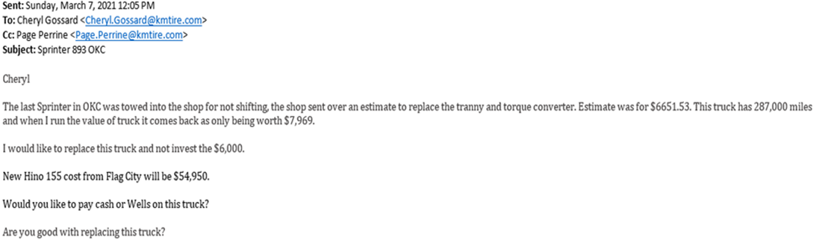

Truck Purchase Scenario’s

Route Addition
During the beginning stage of a route addition, the Fleet Department works closely with Logistics when they are putting together the route proposal on what size or how big of truck is needed for the new route. The Fleet Acquisition Manager will also reach out to the Warehouse Manager, getting the new route on what recommendations he/she has on new truck needs.

To Determine What Truck is Needed:
- What location is getting route addition?
- What current trucks do they have at their location?
    - F:\Warehouse\Scott Warnecke\Trucks and Routes.xlsx
- Is NEW route addition inner city, where a smaller truck is needed or GAS truck?
- Confirm with Warehouse Manager on current “spare” truck(s) at location.
    - Trucks that are nearing the end of their life cycle should be used as spares, so we don’t have new trucks sitting.
    - What repair shops are close for service on trucks?
- What repair shops are close for service on trucks?

Repair Costs > Value of Truck
When repair cost excides the value of truck, a truck request is then sent to president for replacement. How to figure value of truck is laid out in the SOP “Truck Maintenance Approval.”
This spreadsheet is located: F:\Logistics\Shared\Trucks & Trailers\wrecked truck tribune value.xls
- Open file
- Enter “purchase price.”
    - F:\Logistics\Public\Trucks & Trailers\Trucks & Trailers.xlsx
- Enter “current mileage.”
- Spreadsheet will give you a value that K&M / Tribune values truck at, depending on preset life expectancy of truck.
    - Hino 268 – 300,000 miles
    - Mack MD – 300,000 miles
    - Hino 155 – 200,000 miles
    - International Durastar/MV607 – 300,000 miles
    - International CV515 – 250,000 miles
    - Dodge – 250,000 miles
    - Chevy gas – 200,000 miles
    - Ford F650/F750 Diesel – 300,000 miles
    - Ford F350-F550 Diesel – 300,000 miles
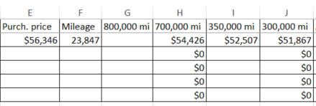
    - When a truck reaches 80% of life expectancy, this is when we determine to replace the truck when the estimate repair exceeds the value of the truck.
    - Cost of truck repairs for last year and truck problems also factor into this figure. If the truck is over $.20 per mile, this needs to be factored in.

Forecast for Truck Replacement
As of 8/23, we have implemented a new forecast to follow to help keep rentals down and cutting down on Maintenance costs. This truck forecast is essential to help support value #1. Ensuring we have a safe and reliable fleet to service our customers.
  - When purchasing a new truck, we need to stick to the forecast and make sure it is updated when a truck is purchased.
  - This can be found on the F drive under F:\Fleet\Shared\Fleet forecast\truck replacement plan.
- Steps that go into determining when a truck will be replaced:
  - Look at the list of trucks based on mileage and sorted by class (type and size of truck). Higher mileage trucks take priority.
    - Looking to replace class 4/5 at 200k miles.
    - Class 6 at 300k miles.
  - Running a cost per mile/ownership analysis.
    - This will help determine if trucks would be beneficial to move up the replacement plan. Below is an example.
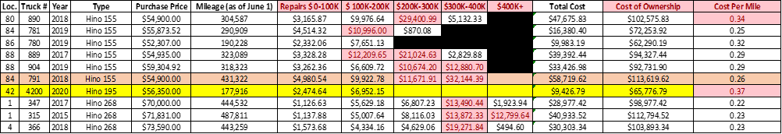

- As seen above, break down the cost of repairs in each 50-100k increment. This gives an idea if the truck repairs are becoming more expensive, and we are better off replacing the truck earlier than planned.
- To calculate the cost per mile, you take the total cost of ownership (including repairs) and divide it by the total miles on the truck.
  - Flag the trucks that are over .20 a mile. These should be more of a priority to investigate and should potentially be moved up on the replacement plan.

Mileage is recorded monthly by the Logistics Department, each month an email goes out to all Warehouse Managers asking them to update the current mileage of all their trucks. This mileage is then entered on the master “Truck and Trailer” excel file on the server: ..\..\..\Logistics\Public\Trucks & Trailers\Trucks & Trailers.xlsx

Here is where the Fleet Acquisition Manager is able to see how many miles are on each truck each month. This makes it visible for the fleet department to double-check with the forecast to make sure our replacement plan and the Truck and Trailers mileage are aligned. Then the Fleet Acquisition Manager can send the truck purchases needed up to the Managing Director-Projects for approval. The Managing Director – Projects will review and touch base with the VP of Ops to ensure the trucks being purchased are in alignment with their expectations. The Managing Director will then send an approval email back to the Fleet Acquisition Manager. The Fleet acquisition manager then sends an email to the President for approval.

Truck Accident
When one of our drivers are invoiced in an “at fault” accident, K&M Tire is self – insured and we are responsible to fix and repair our trucks at our cost all this is out of pocket expense. Once the repair shops send in an estimate for repairs, the Fleet Manager will decide if we repair or send in request to replace. (See 3.2 Repair Cost > Value of Truck)

Preparing Retired/ Wrecked Trucks for Resale
When a truck in our Fleet is retired or wrecked and we will be replacing the truck with a new one, someone from Operations will need to prepare for the truck to be sold.
There are times where we will trade in a truck. Retired will mean either traded in or sold to a private party vendor.

  - Communication is sent by the Logistics Department to the Warehouse Manager / ROM on when a new truck is being purchased and which truck(s) will be retired.

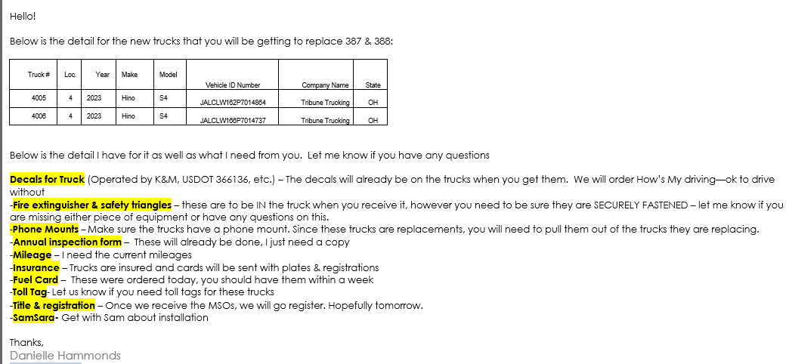

  - After the new truck is delivered to the Warehouse the following items need to be removed from the truck being retired

    - Samsara unit. (Return to Logistics)
    - License Plates Front/Rear (Return to Logistic)
    - Insurance Cards (Throw away)
    - Registration Paperwork (Return to Logistic)
    - K&M Decals Removed and throw away (Heat Gun works best)

      - Operated by sticker.
      - US DOT number
      - K&M Logo
      - How’s My Driving
      - HUT Stickers (NY Locations)

    - All items from inside cab: These items need to be transferred to the new truck unless stated otherwise.

      - Drivers Binder
      - DEF / Antifreeze / Oil / etc.
      - Phone Chargers
      - Fuel Cards (can be cut up and thrown away)
      - Driver Forms
      - Pad Locks & Keys

  - Once all the above items are removed and/or transferred to the new truck, an email needs to be sent to the Fleet Manager, ROM and Logistics that truck is ready to sell. Along with this email, please include five pictures of, driver side, passenger side, rear of truck, front of truck, and inside the cab.

Requesting Truck Quotes
K&M Tire purchases Hino 268 & 155 trucks, Isuzu GAS, and Dodge GAS/Diesel Trucks. Below are the contacts at each of the dealerships. K&M Tire has stayed with Hino brand trucks since 2006, HINO has treated K&M Tire well and preformed to K&M Tire standards. The GAS trucks by Isuzu, and Dodge are trial trucks to see how they perform.

Interstate Truck Source (Hino)
Contact Information:
Email: Al Bryant: al@interstatetrucksource.com
Phone number: 734-991-3998
Email Example:
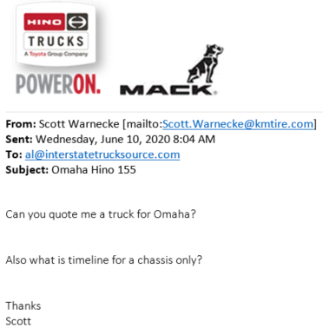
- Note: If K&M has a spare box. Ask how much and timeline for chassis only. This will save from having to buy new box.

Flag City Mack (Hino)
Contact Information:
Email: Brad Comstock: bradcomstock@flagcitymack.com
Phone number: 419-722-0047

Selking International (Isuzu)
Contact Information:
Email: Steve Ostheimer: steveostheimer@selkinginternational.com
Phone number: 260-482-3000

Rush Truck (Hino)
Contact Information:
Email: Trey Wagner: wagner@rushenterprises.com

Crown Motors (Dodge Trucks)
Contact Information:
Email: Craig VerBeek: cverbeek@crownmotors.com

Proposal to Replace Aged Trucks
All new truck purchases must be approved by President. This should only be done quarterly or semiannually. When writing a summary on a new truck purchase proposal, the key is to be as detailed as possible and make sure you’re stating all the facts. Make sure all questions are answered in your email, be as detailed as possible. There should be an explanation, state what the purpose is, etc. Include any spreadsheets or documents that have more information as to “why” you are requesting to purchase a new truck. Include where it is saved. In the closing or bottom of the email is where to use “bullet points” as to what the Fleet Managers’ proposal or thoughts are on the subject.

Writing a Summary

- See below Example:
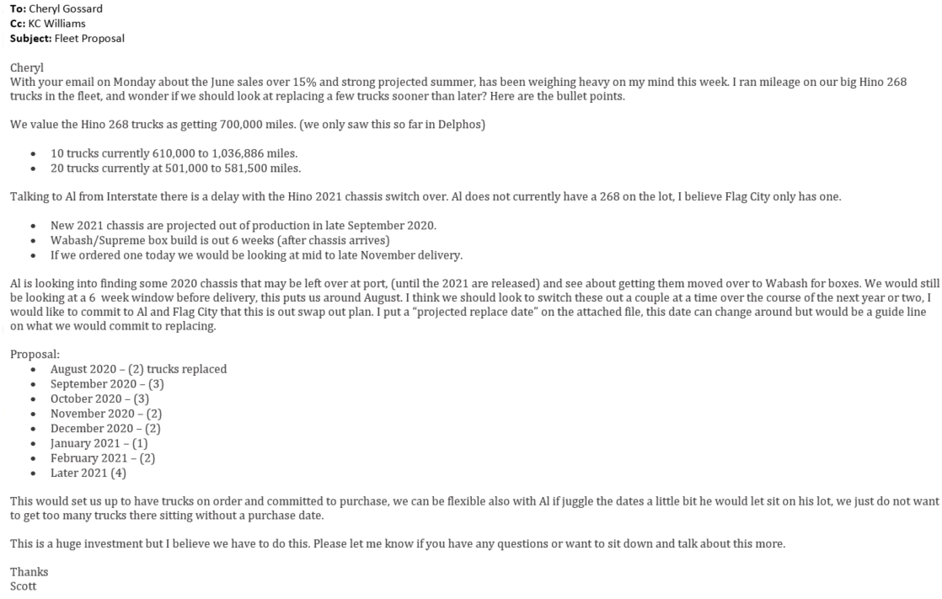

- Example of spreadsheets to attach on proposal emails for more details:
The below spreadsheet should be emailed to the President quarterly or semiannually to request replacement trucks for higher mileage trucks. This also helps alert the President to up-coming purchases and plan for paying cash or financing.
F:\Warehouse\Scott Warnecke\Hino 268 Trucks Replacement Schedule.xlsx
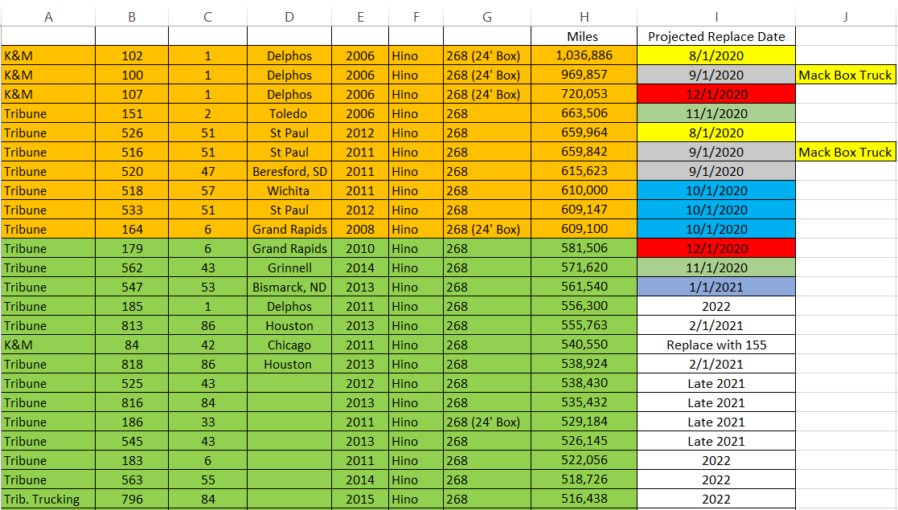

New Vehicle Purchase
Once the decision to purchase a vehicle has been approved by the President, the Fleet Manager will email or bring the vendor invoices to the President.
All vehicles are purchased through Tribune Trucking
The President will notify the Fleet Manager if we will finance or pay cash
If we are paying cash
- Obtain a signature from the President on the vendor invoice.
- Make a copy of the signed vendor invoice to give to the Staff Accountant so they can write the check.
- The check and the original signed vendor invoices go to the Fleet Manager.
If financing we use Wells Fargo Bank
- Obtain a signature from the President on the vendor invoice.
- Email the signed vendor invoice and wiring instructions to Wells Fargo Bank (emails below) & copy the President, Fleet Manager and Staff Accountant
  - Tracy.a.olson@wellsfargo.com
  - Brian.wall@wellsfargo.com
  - Cindy.hargett@wellsfargo.com
  - Nancy.dobbins@wellsfargo.com
- Sample email below
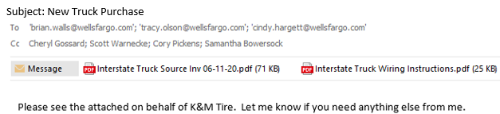

- All of the wiring instructions are saved if it is somebody we have already purchased from, you can find the documents. ..\..\..\Administrative Assistants\Shared\Vehicle Purchase Wiring Instructions If it is somebody new the Fleet Manager can get the information for you.
- Wells Fargo normally replies back letting you know they are working on it. It normally takes 24-36 hours.
- Once they email the completed paperwork back to you. You will need to have the President sign the bank funding documents and email them back to Wells Fargo.
** Wells Fargo will not accept a stamped signature, it has to be a real signature. **
- The original paperwork is then given to the Staff Accountant.
- Wells Fargo emails once the funds have been dispersed and that email needs forwarded to the President, Fleet Manager & Staff Accountant.

Decals and Placement
All decals are ordered from Mushroom Plant Graphics (Lance & Annette Brown)
PH: 419-692-8996 mpg@bright.net

Fleet Manager maintains a supply of all decals needed for the trucks and replenishes the supply as it is depleted. Interstate TruckSource & Flag City also have a supply on hand and they place the decals for us, letting the fleet manager know when they need more decals. If the truck is purchased for another location the decals are sent to the location manager by the fleet manager on transfer to be put on the truck. .Below is the path for the approved placement of the decals.
..\Approved\Decal Placement.docx

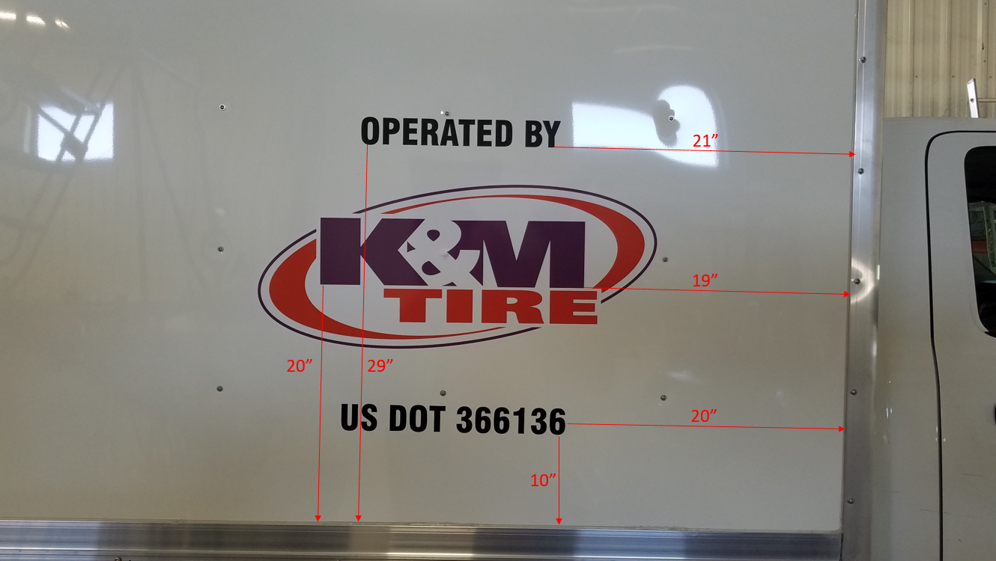

Installing/Uninstalling Samsara Gateways
Installing
- Unbox the gateway and cable that was sent to the warehouse.
- Connect one end of the provided cable to the diagnostic port in the vehicle, typically located below the steering column, and then connect the other end to the gateway.
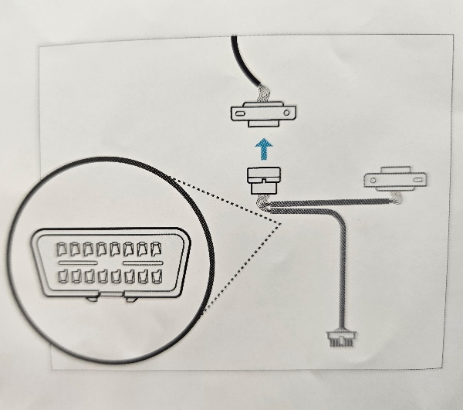

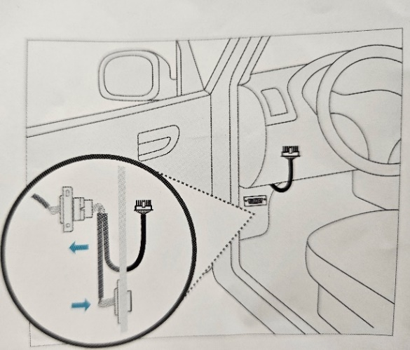

- Once connected, observe the light on the gateway (located where the cable connected)
  - Light will flash orange a couple times but then should turn a solid green.
  - If the light continues to flash orange after 20 minutes, then call Logistics.

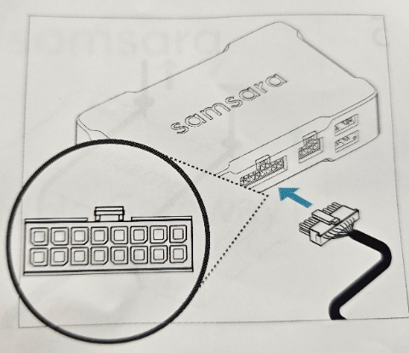

- Use the zip ties included to secure the gateway and cable under the dash of the truck.

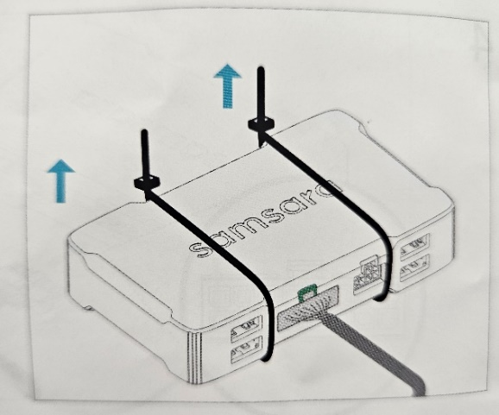

Uninstalling

- Unplug the Samsara cable from the diagnostic port below the steering column in the truck (Leave the cable connected to the Samsara gateway)

- Remove any tape, zip ties or anything else that was used to secure the gateway.

- Send the removed gateway and cable back to Logistics.

Truck Warranty

Manufacturers Truck Warranty
- Hino 268
  - Base vehicle warranty – 24/months – unlimited mileage.
  - Extended engine warranty – 60/months – 250,000 mileage.
  - After treatment system (SCR) – 60/months – 100,000 mileage.
  - Transmission – 36/months – 100,000 mileage.
  - ****FREE TOWING to closet Hino dealer****
- Hino 155
  - Base vehicle warranty – 36/months – unlimited mileage.
  - Extended engine warranty – 60/months – 200,000 mileage.
  - After treatment system (SCR) – 60/months – 100,000 mileage.
  - Transmission – 36/months – 100,000 mileage.
  - ****FREE TOWING to closest Hino dealer****
- Sprinters – all current fleet is out of warranty, no new purchases of Sprinters.
  - Sprinter trucks are not purchased any more due to high maintenance cost and up keep. Sprinters were last purchased in 2016.
- Isuzu (GAS)
  - Base warranty – 36/months – 36,000 mileage.
  - Transmission – 60/months – 75,000 mileage.
- Dodge 5500 (GAS)
  - Base warranty – 36/months – 36,000 mileage.
  - Transmission – 60/months – 60,000 mileage.
- Dodge 5500 (DIESEL)
  - Base warranty – 36/months – 36,000 mileage.
  - Transmission – 60/months – 100,000 mileage.
- Dodge 4500/3500 (GAS)
  - Base warranty – 36/months – 36,000 mileage.
  - Transmission – 36/months – 36,000 mileage.

Extended Warranty
Some new trucks are purchased with “Extended Warranty” on the after treatment (SCR), this is part of the purchasing negotiations. When the truck has an “Extended Warranty” this will be listed on that trucks Maintenance Log for mileage coverage.

Truck Maintenance Approval
To help control the cost of truck maintenance on K&M Tire Fleet. The Warehouse Managers will email a copy of the repair estimate and parts breakdown to the Fleet Manager for any repair estimates over $1500.00. The Fleet Manager will review the estimate and pricing and send back an approval or denial email to the Warehouse Manager.

K&M Own Use Tires
With over 500 vehicles out on the road, K&M will need to bill out tires to help keep our fleet safe and obey DOT regulations. Weather and the time of the year can determine when we should be replacing the tires on our trucks. The standard we currently follow is:

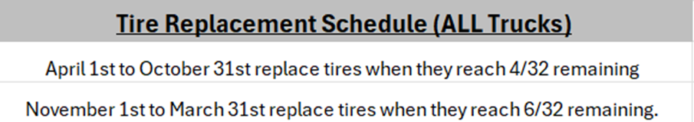
When the tires are at the wear level to be replaced or we have an emergency and need to replace a tire, we want to bill out tires from our own warehouses. We have Own Use accounts set up for every location. We need the vehicle number, mileage, and if you need steer tires or drives. Here are the steps to bill them out in Madden Co. This is for Warehouse Managers, ROMs, and Fleet to complete.

- 1 Tire Dealer System – enter

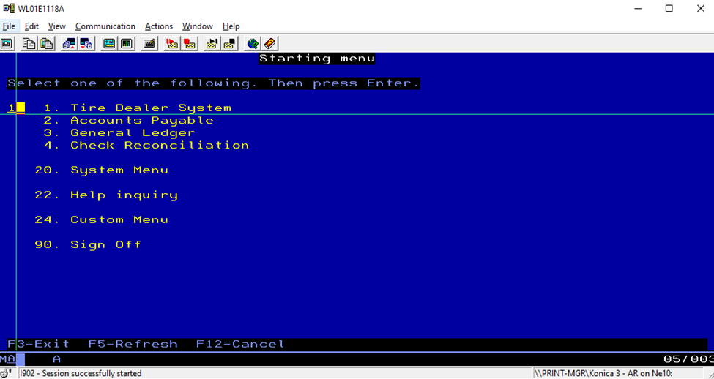

- 7 Warehouse Order Entry – enter

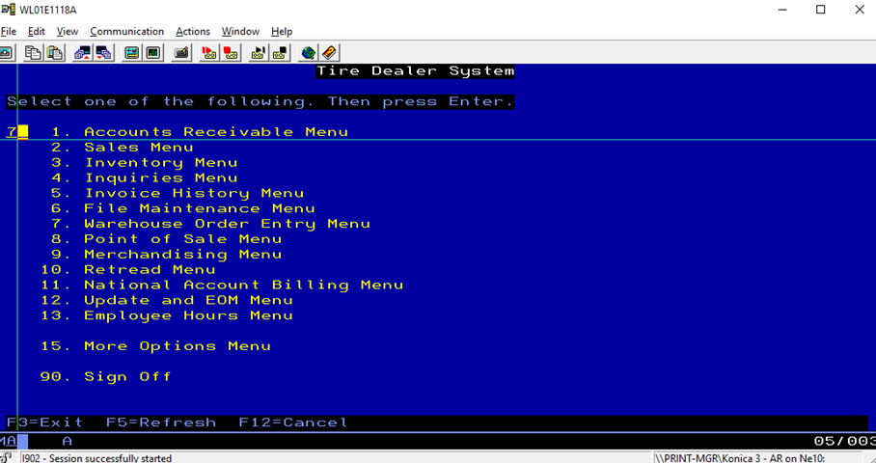

- 1 Order Entry- enter

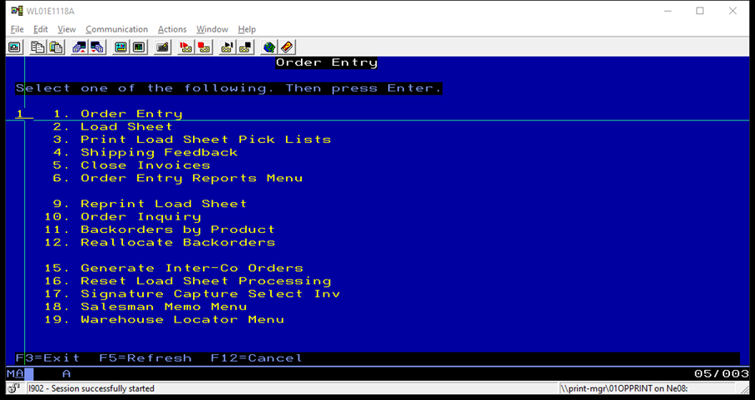

- Enter Location number the tires are being billed out for – field exit/enter

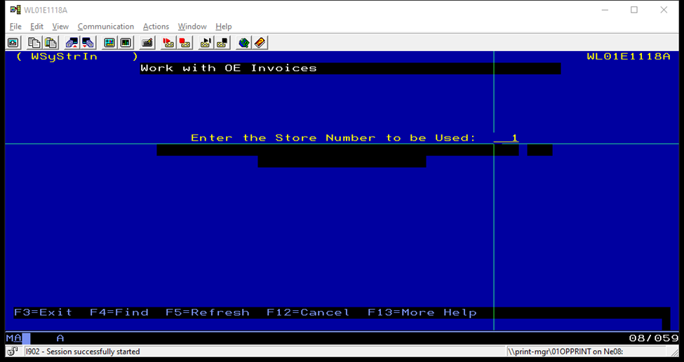

- Then you need to enter the bill to account on the Customer line (Ex. Delphos is 199995). – enter **Note the procedure to find K&M Own Use Accounts section.

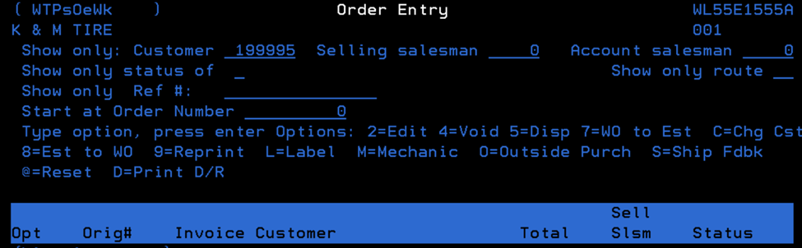

- Press F2 to search for the tire size you need. On the “display by size” line, enter the size (without any dashes or hyphens) and press enter.

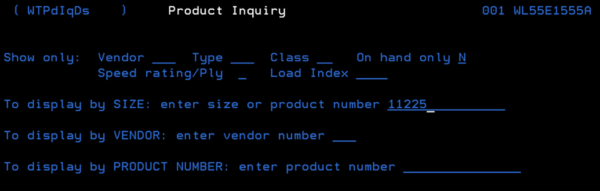

- This will bring up a list of all the tires we have in that size. It shows “available here” so you can see what tires are in stock. Typically, we go with Roadmaster, Double Coin, Super Cargos, or Ironhead brands if available. Put the number of tires needed on the line next to the product number and press enter. (ex. The 4 on the IH9630495 below).

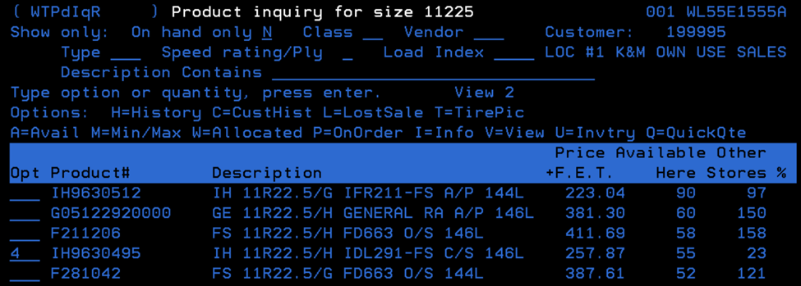

- A box will pop up to Start Estimate or Order. Put a “I” on the line for New order. Press enter.

- You’ll have to enter your salesman number in the top right of the next screen. Also, make sure PU is listed as the Route code. Press enter.

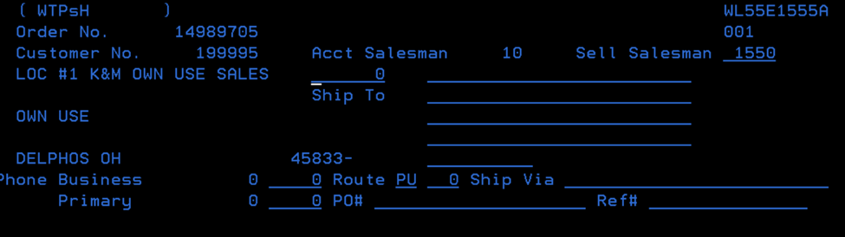

- Then you’ll go to the Work with Work Order screen which should have your product and quantity. Next, we need to add the message on the invoice referencing the truck # and current mileage of that vehicle. Put a “M” on the line next to the item and press enter.
  - Enter your vehicle number and current mileage. Press enter.

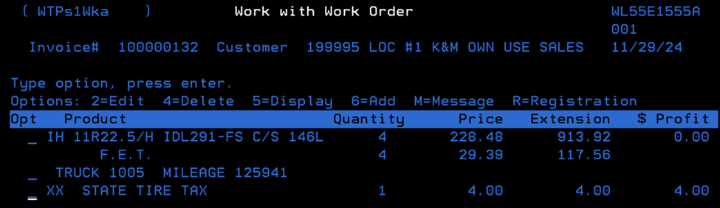

- This order needs to be billed out as a Will Call. Press F6 to add a line item. Next to the product line, type WILL CALL. Press enter.

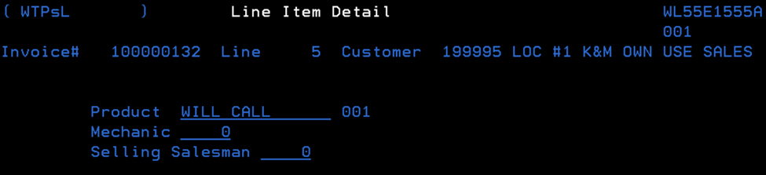

- Put a 1 on the Quantity line and field exit. Press enter.

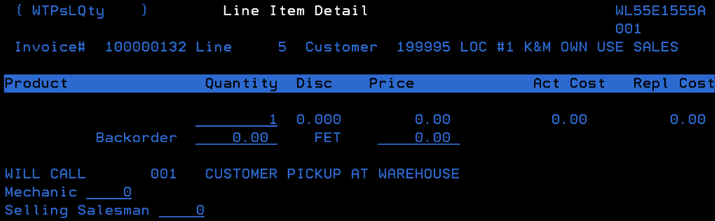

- Press F3 three times. This will take you back to the Order Entry screen and your invoice will be ready for sales to print.

- Make sure the Warehouse managers are entering the new tires on the Maintenance Dashboard/Logs.

Finding K&M Own Use Accounts

- After completing steps 1-4 above, you’ll be at the Order Entry screen. Press F4 when you are on the Show Only: Customer line in the top left.

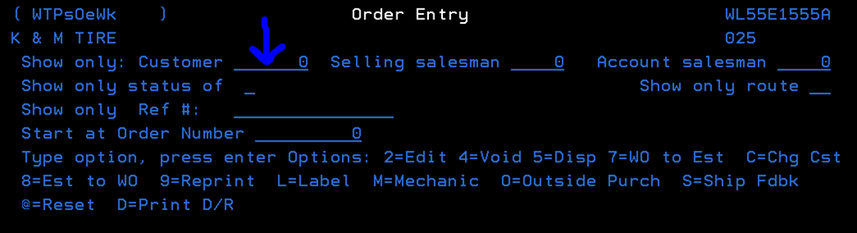

- Takes you to the Customer Inquiry screen. On the Customer Name line, type ZZZLOC and the location you are billing out the tires for. (ex. L49 here).
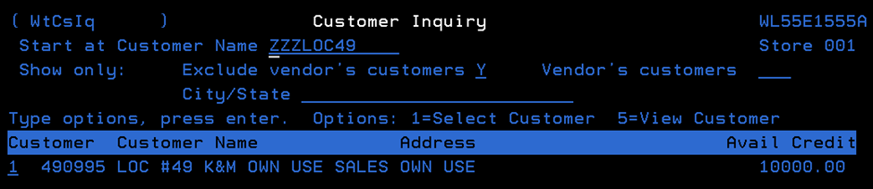

This will show the K&M Own Use account we want to use to bill out tires. Put a 1 next to the account number as shown above. Press enter.

Maintenance Intervals
The purpose of this S.O.P. is to explain the maintenance intervals that we have in place for our fleet. This will also include how to calculate and look at the Cost Per Mile of a truck. The cost per mile is an important part of the maintenance for our trucks, we can look at the CPM to determine if we need to do something different with our maintenance intervals, or if we need to retire a truck.

Why do we look at maintenance intervals.
  - We look at the maintenance intervals to make sure that we are staying up to date on Oil changes, Transmissions services, fuel filters, belts, and on applicable models, DEF filters. This is a crucial step in keeping a good working fleet in order.

What are our maintenance intervals.
- Our maintenance intervals are set in miles. This determines how far we can drive a truck before it is due for any type of service, like an oil change. We review these intervals in 2 ways; what are the manufacturers recommended intervals and based off of history, what intervals/segments do we at K&M want to reduce. However, there are some cases where the interval may be working just fine for us, but the manufacturers may recommend getting services done sooner.

What are the manufacturers’ maintenance intervals.
- To look at what the manufacturers’ maintenance intervals are, we first need to figure out what truck we are working with.
- Once you determine what truck you are working with, Year, Make, Model, Engine, fuel type, then we can go to the manufacturers website and look up suggested service intervals.

When do you calculate the maintenance intervals
- When getting a new truck, one of the first things you will need to do is calculate the maintenance intervals.
- The other time that you will calculate the maintenance intervals is twice per year. You will calculate them once at the beginning of January and once at the end of June.

Why do you calculate the maintenance intervals.
- Staying up to date on the maintenance intervals is very important. This is important because manufacturers can change their intervals, or we may find that we have higher repair bills and tightening up the service intervals could help keep us from having those higher bills.
- Once you have the manufacturer’s suggested service intervals, we can then compare them to ours and see if we need to adjust. If there are adjustments that need to be made, then we will update the maintenance intervals sheet located on the F-drive, under Warehouse, Shared, Maintenance logs, then send it for approval from the managing director-Projects. Once approved, we then will send it to I.T. and this will be sent to an I.T. developer. so that they can upload the new intervals into the maintenance dashboard on the Intranet and with logistics to update samsara.

How do you calculate the maintenance intervals.
- To calculate the maintenance intervals, you will first look up the manufacturers’ recommended intervals. After looking up the Manufacturers recommendations, you will then compare them to what we have been doing. If you notice that there are some that need to be changed or some that would benefit from being changed you can bring this up to the Managing Director – Projects.
- Once you have reviewed these with the managing director -projects, the decision will then be made either to keep the current intervals or update them with the new ones.

Cost per mile.
- What is the cost per mile.
  - The cost per mile is exactly as it sounds; it is how much a truck costs for the company to run per mile that it is driven.

How do you calculate cost per mile.
- To calculate the cost per mile of a vehicle, you will look at a period of miles, we use a baseline of 50,000 miles. Once you have the baseline, you take the cost of all the repairs over that period of miles and divide them by the miles driven, this will give you the amount that we spent per mile driving the truck. Example: $25,000/50,000 miles = $.50/Mile

Why do you calculate cost per mile.
- The reason you calculate cost per mile on a truck is to see if the truck is starting to cost more money to run than what it’s worth.
- If you have a truck that goes in for repairs and the bill is high, then you will go back and look at the maintenance records for the truck and see what the cost per mile is. After you do that then you can determine if the truck is worth fixing or if the truck is starting to cost more per mile to run than we would like to see. Our thresholds are anything $.15/mile is acceptable. Any truck between $.16 - $.25 needs to be on the radar. Any truck over $.25 we need to start planning to get it moved out of our fleet lineup.

When is the cost per mile important.
- Cost per mile is important for the life of the vehicle.
- Ideally you want to keep the CPM as low as possible for the entire life of the vehicle, so you get the best return on investment.
- If you have a truck that has a lower CPM, you might be able to run it a little longer than that of a truck that has a higher CPM.
- This also translates into selling the truck. If you have a truck that has a lower CPM and is in overall better condition, then you will be able to get more out of it at the time of sale.

Fleet Schedule (Manager’s)

Maintenance Schedule
Managers are instructed to follow the Maintenance Schedule outlined on the F: Drive when to schedule their fleet in for PM service. This schedule follows the manufactures guidelines in the owner’s manual and in line with the warranty on the trucks. PM Service should be done within a +/- 1,000 mile window. The Maintenance Schedule can be found: F:\Warehouse\Shared\Maintenance Logs\Maintenance Schedule NEW (4-10-18).doc
There are a few reasons why it is critical for the Warehouse Manager to follow the Maintenance Schedule, the most important one is truck Safety for the drivers and other parties on the road every day, another reason is the longevity of the truck, being able to get the most miles out of our trucks before we replace, giving K&M the best ROI on the truck. Doing regular PM on time also protects the manufactures warranty on the truck.

Maintenance Schedule Example
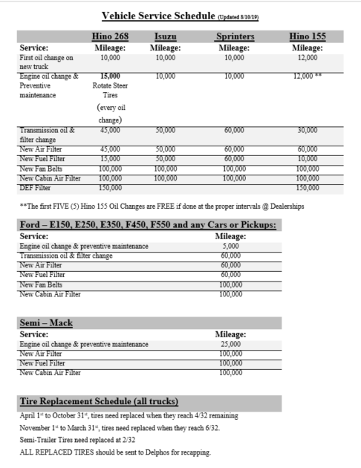
Notes:
- Hino 155 Trucks receive “FREE” PM Service up to 60,000 miles. This includes 5 services done every 12,000 miles, +/- 1,000 miles.
- Hino 268 Trucks should have steer tires rotated every PM to extend the life of the tires, this PM is every 15,000 miles.

Maintenance Log (Manager’s)
When ANY service or PM’s are completed on K&M’s Fleet, the manager must update the Maintenance Log on the file server with, date, mileage, repair shop, a detailed description of service completed, shop invoice number, cost and initials of who updated the Maintenance Log. Maintenance Log can be found: F:\Warehouse\Shared\Maintenance Logs

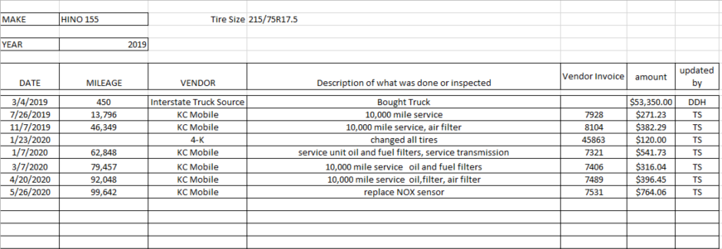
** The Maintenance Log is laid out on the F:Drive each location has their own log and tabs across the bottom of the Excel sheet for each truck at that location.
Example:

Having the correct mileage, date of service and detailed description is key when truck goes back in for same service within one year of last replacement or if the truck is still covered by manufacturer’s warranty. This information helps the Fleet Manager learn items that are covered under warranty or cost passed on the Vendor for payment. Items correctly entered in Maintenance Log also helps with replacement and when K&M Tire should retire trucks.
This log is reviewed and analyzed monthly by the Fleet Manager to make sure maintenance is being done in a timely manner and to alert him to any impending truck problems.

Estimate Approval / Denial

Estimate Review
- Open email containing the estimate from repair shop.
- Locate truck number and mileage.
- Open Maintenance Log for that location on F:Drive and locate tab for truck in repair.
  - F:\Warehouse\Shared\Maintenance Logs
QUESTIONS:
- Was any previous work done for same service within 1 year (calendar)?
  - If YES, email manager of location sending in estimate for approval letting him/her know repairs will be covered under warranty.
- Is truck still covered under manufacturer’s warranty? (see warranty tab)
  - If YES, email manager / shop letting them know repairs will be covered under warranty.
- What is mileage of truck?
- What is cost of repairs?
- Is truck worth fixing or need replaced? (see truck value tab)

- Check pricing of part.
  - High dollar parts should be in line with what K&M Tire pricing is through Interstate Truck or Flag City. Email Grady – grady@interstatetrucksource.com and Al – al@interstatetrucksource.com to do a price check. If pricing on estimate is higher, that is when we question repair shop on why the pricing is higher and if they will match Interstate or Flag City parts pricing.
- Double check labor rate we are being charged, should fall between $80 and $110 per hour.
- Question anything else on estimate that truck did not go into shop for, look for items we should be repairing at warehouse to save cost. Example: wiper blades, headlights bulbs, tail light bulbs, running lights, filling washer fluid. (places like Auto Zone or O’Reilly will replace these items with no install cost).

Estimate “Approval”
- Once “approval” has been decided an email needs sent to manager stating it is OK to repair truck per estimate.

Estimate “Denied”
- If estimate is going to be “denied” send an email to President before final decision is made, (See SOP Truck Purchase / Approval). This email should state what the issues are with truck, what estimate total is for repairs, mileage of truck and what is the value of truck from “wrecked truck tribune value” spreadsheet. F:\Logistics\Shared\Trucks & Trailers\wrecked truck tribune value.xls
- Once email is back from President on the OK to replace.
- Send an email to Manager stating we will not be fixing the truck the estimate is denied. We would be replacing the truck, go ahead and have truck moved back to warehouse where Fleet Manager will either trade in or find a buyer to purchase truck.

Truck Value

Truck Value Spreadsheet (AKA Wrecked Truck Tribune Value)
This spreadsheet is located:
F:\Logistics\Shared\Trucks & Trailers\wrecked truck tribune value.xls
- Open File
- Enter “purchase price”
  - F:\Logistics\Shared\Trucks & Trailers\wrecked truck tribune value.xlsEnter “current mileage”
- Spreadsheet will give you a value that K&M Tire / Tribune values truck at, depending on present life expectancy of truck.
  - Hino 268 – 700,000 miles
  - Hino 155 – 350,000 / 450,000 miles
  - Sprinter – 300,000 miles
  - Dodge – 400,000 miles
  - Chevy & Fords – 350,000 miles

- When truck reaches 80% of life expectancy, this is when we determine to replace the truck when the estimate repair exceeds the value of the truck.
- Cost of truck repairs for last year and truck problems also factor into this figure.

Freight Billing
K&M Tire partners with Niece Trucking to pick up and deliver tires to our own warehouses in Delphos, OH; Lincoln Park, MI; Columbus, OH; DeKalb, IL and Arlington, TX. Because K&M Tire effectively pick up our own loads in these instances, we bill the vendors for freight. The Bill of Ladings (BOL) documents are given to the Fleet Manager by Niece. Once the Fleet Manager finishes tracking, they will bring the BOL’s to the person responsible for the task of Freight Billing once a week for that week’s billing.

BOL tracking is kept in an Excel spreadsheet located: F:\Administrative Assistants\Shared\Freight Billing\FREIGHT BILLING new (3).xls

Vendor that we bill for freight include, Firestone (FS), Continental General (CG), Goodyear (GY), and Cooper Findlay (CP).

Vendor pick up for Hankook (HK) loads take 2% off tire invoice balance, Cooper (Franklin) deduct Freight Allowance off tire invoice.

In this written procedure each vendor’s process will be defined and a step by step walkthrough will be given.

Firestone (FS) 514349 (BS-FS Tab)

Firestone / Bridgestone Excel Tab
F:\Administrative Assistants\Shared\Freight Billing\FREIGHT BILLING new (3).xls
- Column A – Enter the Driver’s name.
- Column B – Enter the pick – up date.
- Columns C & D – Enter location stop (s); Delphos symbolized by D, Lincoln Park symbolized by LP, DeKalb symbolized by DK, or Delphos to DeKalb * also referred to as a “split load” symbolized by D,NM,DK.
- Column E – Enter a “1” only if it is a Delphos / Dekalb split load, otherwise leave this column blank.
Column F – Enter the cost of fuel for the week in which the load was picked up. This info is accessible at the website: https://www.eia.gov/petroleum/gasdiesel/?src=email (only look at the US row)
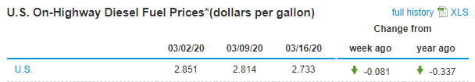
- Column G – Enter the total weight of load. If you are entering info for a split load, be sure to add the “weight totals” from both the Delphos and DeKalb load. Total weight found in middle of BOL.
- Column H – Enter the “Shipment number” found in the top LEFT corner of the bill of lading.
- Columns I to P – These columns are all pre – filled with formulas & information that remains the same no matter what. SO NOT TYPE IN THESE CELLS.
- Next, bill out an invoice for each BOL line from excel.

Firestone / Bridgestone MaddenCo
- Open MaddenCo
  - (1) – Tire Dealer System
  - (8) – Point of sale menu
  - (4) – Counter billing
  - (001) – Enter all invoices in location 1
- Bridgestone / Firestone – Customer #514349 (Williams and associate)
  - Enter FS Customer #514349
  - Hit F6 – start new invoice
  - Hit F6 – issue a new invoice number
  - Enter
  - Enter the product codes needed then field exit (+ key)
    - F1 = Delphos
    - F2 = Toldeo
    - F3 = Solon
    - F4 = Lincoln Park
    - F42 = DeKalb
  - Hit enter
  - Enter “1” in quantity then field exit (+ key)
  - Enter
  - If there is two stops on the Bill of Lading use product code FS + location number of second stop. (this is when FS Truck tires are ordered for DeKalb – they are ordered for K&M Tire at 502 N. Main)
    - First stop is always the stop farthest from Firestone.
      - EX: Delphos / DeKalb is F1 then FS42
      - EX: Delphos / Lincoln Park is F4 then FS1
  - Use “S1” nect to bill the fuel surcharge – field exit (+ key)
  - Enter
  - Enter “1” in the quantity – field exit (+ key)
  - Tab over to price line
  - Enter the fuel surcharge from FREIGHT BILLING spreadsheet on the BS – FS tab column “K”
  - Enter
  - Hit F3 – this will allow you to review all that you have entered and confirm it is correct on the invoice. (The grand total on the invoice in MaddenCo should match column “L” on FREIGHT BILLING spreadsheet)
  - Hit F7 to add message to invoice. Enter Vendor Reference Number or BOL Number, Delivery Date the load was picked up at Vendor and the weight.
  - Enter
  - Hit F3 to end invoice. Invoice will print automatically.
  - Once all invoices are printed, match invoice to the Vendor BOL, file invoice and BOL in file Fleet Manager has until bills are paid and off Vendor statement.
  - Highlight date column in “purple” when all loads are invoiced in MaddenCo. This will be your start / stop point when you enter loads next week.
  - Enter all invoices on Syncada website. (BS / FS uses USBANK to pay K&M Tire)

Syncada Firestone / Bridgestone
- https://portal.syncada.com/Syncada/Login.aspx
- User Name and password will be updated in the notes area. (password changes every 60 days)
- Click open and choose “Invoice Manager” second window will open.
- Hover over save tab (to left)
  - Drop down box to “ System Searches”
  - Drop down to “Unmatched Buyer”
- This will bring up the BOL’s that Firestone has uploaded into the system for payment.
- Match the BOL that you are working on with the BOL system. Select or check mark the box to the left of the BOL number.
- Tabs at the top select “New” than “invoice from older”
- Invoice number box, put in K&M invoice number form MaddenCo.
- Click on “Add/View Statue”
  - Put in actual ship date (Signed date by driver)
  - Under status select “delivered”
    - Then “Add and Close”
- Check “Billed Amount” (top left) this amount should match amount on K&M invoice (give or take a few cents)
- Amount match click “SAVE”
- Amount doesn’t match:
  - Scroll to last page under “Line Details”
  - Look for “Fuel Surcharge” line
  - Click in box under “Billed Extended”
  - Change amount for Fuel Surcharge amount to match K&M invoice for Fuel Surcharge
  - Click save
- For “split loads” or when code is “S,NM,B” you will need to choose “line item distribution”
  - Change pricing from 650 to 850
  - Save (yes you really want to save)
  - Change miles from 459 to 238, under “Fuel Surcahrge” on last page in line items.
  - Make sure “stop charge” of $75.00 has qty of “1”
  - Save

Syncada Invoice Statement
- Statement will be ready next day after billing F/S.
- Log into Syncada (See notes)
- Choose “Open” tab
- Choose “Daily Statements” (second box opens)
- Choose K&M account, there is only one
- Select statement day, it will automatically pull the most recent statement
- Submit
- Print off statement and give to A/R Supervisor

Syncada Notes
- Username – Dburgei
- Password – Payables_(3) current password, changes every 60 days
- Security answers
  - Walking
  - Cabo
  - Lima

Continental / General (CO / GE) 1005593 (C – GE Tab)

Continental / General Excel Tab
- Column A – Enter the driver’s name
- Column B – Enter the pick – up date
- Columns C & D – Enter location stop(s); Delphos symbolized by D, Lincoln Park symbolized by LP.
- Column E – Split loads are not done so this column will be left blank.
- Column F – Enter the cost of fuel for the week in which the load was picked up. This info is accessible at the website: https://www.eia.gov/petroleum/gasdiesel/ you will check the “US On – Highway Diesel Fuel Prices (only look at the US row).

- Column G – Enter BOL number found in the TOP RIGHT corner on page one of the Bill of Lading.
- Columns H thru P – these columns are all pre – filled with formulas & information that remains the same. DO NOT TYPE IN THESE CELLS.
- Next, bill out an Invoice for each BOL line from excel.

Firestone / Bridgestone MaddenCo
- Open MaddenCo
  - (1) – Tire Dealer System
  - (8) – Point of Sale Menu
  - (4) – Counter Billing
  - (001) – Enter all invoices in Location 1
- Continental / General – Customer # 100593 (Excel – Continental Tire)
  - Enter CO / GD Customer # 100593
  - Hit F6 – Starts new invoice
  - Hit F6 – Issues a new invoice number
  - Enter
  - Enter the product codes needed then field exit (+ key)
    - CG1 = Delphos
    - CG2 = Toledo
    - CG4 = Lincoln Park
  - Hit Enter
  - Enter “1” in quantity then field exit (+ key)
  - Enter
  - If there is two stops on the Bill of Lading enter product code CGS
    - In the message field on invoices list the city of stop.
  - Add product CGU (CO/GE) pays an unload fee)
  - Use “S1” next to bill fuel surcharge – field exit
  - Enter
  - Enter “1” in quantity – field exit
  - Enter
  - Tab over to price line
    - Enter the fuel surcharge from FREIGHT BILLING spreadsheet on the C-GE tab column “F”
  - Enter
  - Hit F3 – This will allow you to review all that you entered and confirm it is correct on the invoice. ( the grand total on the invoice in MaddenCo should match column “L” on the FREIGHT BILLING spreadsheet)
  - Hit F7 to add message to invoice. Enter Vendor Reference Number for BOL Number, Delivery Date the load was picked up at Vendor and the weight.
  - Enter
  - Hit F3 to end invoice. Invoice will print automatically.
  - Once all invoices are printed, match invoice to the Vendor BOL, file invoices and BOL in file Fleet Manager has until bills are paid and off Vendor Statement.
  - High – lite date column in “purple” when all loads are invoiced in MaddenCo. This will be your start / stop point when you enter loads next week.
  - Invoices and BOL need scanned into an email and forward on to Terry Gouge (terry.gouge@conti-na.com)

Goodyear (GY) 101167 (GY Tab)

Goodyear Excel Tab
- Column A – Enter the driver’s name
- Column B – Enter the pick – up date
- Column C – Enter the stop location, Delphos = D, Lincoln Park = LP, or DeKalb = DK
- Column D – Split loads are not done for Goodyear, column will be left blank
- Column E – Enter the Shipment Number located in the top right corner of the Bill of Lading
- Columns F thru H and J – these columns are all pre – filled with formulas & information that remains the same. Do NOT TYPE IN THESE CELLS
- Column I – Enter Fuel Surcharge
  - Tab labeled “GY Fuel Surcharge Amounts” find the amount of fuel cost for the week. This info is accessible at the website https://www.eia.gov/petroleum/gasdiesel/ You will check the “us On – Highway Diesel Fuel Prices (only look at the US row).

  - Fuel Surcharge will be &0.** (In Cents)
  - Column I – change the formula to reflect fuel surcharge (Bold 0.26)
    - =ROUND (H19*0.26,0)
  - Next, bill out an Invoice for each BOL line form Excel

Goodyear MaddenCo
- Open MaddenCo
  - (1) – Tire Dealer System
  - (8) – Point of Sale Menu
  - (4) – Counter Billing
  - (001) – Enter all invoices in Location 1
- Goodyear – Customer # 101167
  - Enter Goodyear Customer # 101167
  - Hit F6 – Starts new invoice
  - Hit F6 – Issues a new invoice number
  - Enter
  - Salesman number
  - Enter the product codes needed then field exit (+ key)
    - G1 = Delphos
    - G4 = Lincoln Park
    - G42 = DeKalb
  - Hit Enter
  - Enter “1” in quantity then field exit (+ key)
  - Enter
  - If there is two stops on the Bill of Lading enter product code G12
    - In the message field on invoices list the city of stop.
  - Use “S1” next to bill fuel surcharge – field exit
  - Enter
  - Enter “1” in quantity – field exit
  - Enter
  - Tab over to price line
    - Enter the fuel surcharge from FREIGHT BILLING spreadsheet on the GY tab column “I”
  - Enter
  - Hit F3 – This will allow you to review all that you entered and confirm it is correct on the invoice. ( the grand total on the invoice in MaddenCo should match column “J” on the FREIGHT BILLING spreadsheet)
  - Hit F7 to add message to invoice. Enter “Carrier Invoice Ref Number”, Delivery Date the load was picked up at Vendor and the weight.
  - Enter
  - Hit F3 to end invoice. Invoice will print automatically.
  - Once all invoices are printed, match invoice to the Vendor BOL, file invoices and BOL in file Fleet Manager has until bills are paid and off Vendor Statement.
  - High – lite date column in “purple” when all loads are invoiced in MaddenCo. This will be your start / stop point when you enter loads next week.
  - Enter all invoices on JDA, this is the website that pays K&M for freight.
    - www.goodyear.com/tms

Goodyear JDA Website
- www.goodyear.com/tms
- Username and password will be updated in notes area (password change every 60 days)
- Click on “+” symbol next to “Actions”
- Add Invoice screen will open. On this page you will need to enter:
  - K&M Invoice Number
  - Carrier ID: KMTK
  - Weight of load
  - Invoice BOL (This is GY Carrier Invoice number)
  - Ship Date (Day load was picked up by driver)
- Hit Next (not Done)
- Add Invoice: Geography screen will open. On this page you will need to enter:
  - Origin Name – Goodyear Tire & Rubber
  - Destination Name – K&M Tire INC
  - Origin City – GY location were load was picked up from
  - Origin State - GY location were load was picked up from
  - Origin Postal Code - GY location were load was picked up from
  - Destination City – K&M location where load is going
  - Destination State - K&M location where load is going
  - Destination Postal Code - K&M location where load is going
- Hit Next (not Done)
- Skip Add Notes screen
- Hit Next
- Click on the “+” sign
- Enter “Cost Qualifier” – Haul Cost
- Enter Qty Measure – Weight
- Enter “Amount” – Freight amount from K&M Invoice (do not include the fuel surcharge)
- Hit Next
- Click on the “+” sign
- Enter “Accessorial ID” – FUE
- Enter Qty. Measure – Weight
- Enter “Amount” – Fuel Surcharge amount from K&M Invoice
- Hit Done
- Screen will go back to add another invoice screen.

JDA Website Notes
User name: KMTK_joverholt
Password: Goodyear12

Cooper Findlay to Franklin 212660 (Cooper)

Cooper Findlay Excel Tab
- Column A – Enter the driver’s name
- Column B – Enter the pick-up date
- Column C – Enter the BOL Number located in the top RIGHT corner of the Bill of Lading.
- Column D – Enter the cost of fuel for the week in which the load was picked up. This info is accessible at the website http:/eia.gov/petroleum/gasdiesel. You will check the “US On-Highway Diesel Fuel Prices (only look at the US row). https://www.eia.gov/petroleum/gasdiesel/

- Column E – This column is left blank.
- Column F thru K – these columns are all pre-filled with formulas & information that remains the same. DO NOT TYPE IN THESE CELLS.
- Next, bill out an Invoice for each BOL line from Excel.

Cooper Findlay MaddenCo
- Open MaddenCo
  - (1) – Tire Dealer System
  - (8) – Point of Sale Menu
  - (4) – Counter Billing
  - (001) – Enter all Invoices in Location 1
- Cooper – Customer # 212660
  - Enter Cooper Customer # 212660
  - Hit F6 – starts new invoice
  - Hit F6 – issues a new invoice number
  - Enter
  - Enter the product code needed then field exit (+ key)
  - CP1 = Delphos
- Hit Enter
- Enter “1” in quantity then field exit (+ key)
- Enter
- Use “S1” next to bill fuel surcharge – field exit
- Enter
- Enter “1” in quantity – field exit.
- Enter
- Tab over to price line
  - Enter the fuel surcharge from FREIGHT BILLING spreadsheet on the Cooper Findlay to Franklin tab column “H”
- Enter
- Hit F3 – this will allow you to review all that you entered and confirm it is correct on the invoice. (The grand total on the invoice in MaddenCo should match column “I” on the FREIGHT BILLING spreadsheet)
- Hit F7 to add message to invoice. Enter “Carrier Invoice Ref. Number”, Delivery Date the load was picked up at Vendor and the weight.
- Enter
- Hit F3 to end invoice. Invoice will print automatically.
- Once all invoices are printed, match invoices to the Vendor BOL, file invoices and BOL in file Fleet Manager has until bills are paid and off Vendor statement.
- High-lite date column in “purple” when all loads are invoiced in MaddenCo. This will be your start/stop point when you enter loads next week.

Reviewing Vendor Statements (Monthly)
Monthly Vendor Statements are sent via email to Fleet Manager on the 1st day of the month. Statements need reviewed and any “Past due” invoices need followed up for payment.

Vendor Statements
- Pull the completed Invoices and BOL from file folder.
- Open up first vendor statement email.
- Match invoice numbers to statement.
- Any invoice not on statement means this invoice was paid. If the invoice was paid this BOL and Invoice can be recycled no need to keep.
- Any invoice that is still on statement look to make sure invoice is not “past due”.
- Refile all good standing invoice and BOL until next month.
- If an invoice is “past due” email the below contacts to clear up:
  - Firestone – Sheila.goodin@usbank.com
  - Cooper – SLCaudill@coopertire.com
  - Continental – Terry.Gouge@conti-na.com
  - Goodyear – Freightaccounting@goodyear.com or Kimberly_holmes@goodyear.com

K&M Forklifts & Squeeze Clamps

Standards on Forklifts / Squeeze Clamps
Below are the standard forklift guidelines we go by when we start looking for quotes on new clamps or forklifts to purchase. (If we are looking for used, we want to be under 2,000 hours. There are more repairs & cost for forklifts over 2,000 hours).

- LP / Propane Gas
- 5,000 # lift capacity
- Solid Foam Filled Tires
- 48” Fork (or)
- 77” clamp opening (Hub Locations)

Forklift/Squeeze Clamp Forecast
As our equipment gets used/older, we need to be proactive with our ordering and replacement equipment so the warehouses can function without interruption. Sometimes it could take a few months to get a lift in once it’s ordered. Toward the end of the calendar year, we need to plan and get a forecast put together for the following year.
F:\Fleet\Shared\Trucks and Routes.xlsx **Then find the Forklift Forecast tab.

- First you need to compile a list of the total hours of each of our lifts to see which machines are older. These are the ones that will be planned to be replaced first.
  - Managers update a file on Teams quarterly (Example below) with the current hours.
  - All lifts over or approaching 13,000 hours should be considered top priority for replacement in the next few quarters of the calendar year.
  - This guarantees we will get the equipment replaced before it hits the 15,000-hour threshold.

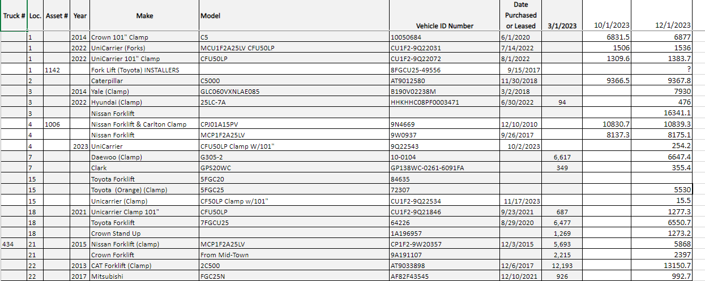
- Reach out to the locations that have lifts with 13,000+ hours and get an update on the overall functionality and condition of the unit.
- This will help us plan what to do with the one we are replacing.
- We could look to sell old lifts or potentially use them in another warehouse that could benefit from having another squeeze clamp or the possibility of switching it to be used as a forklift.

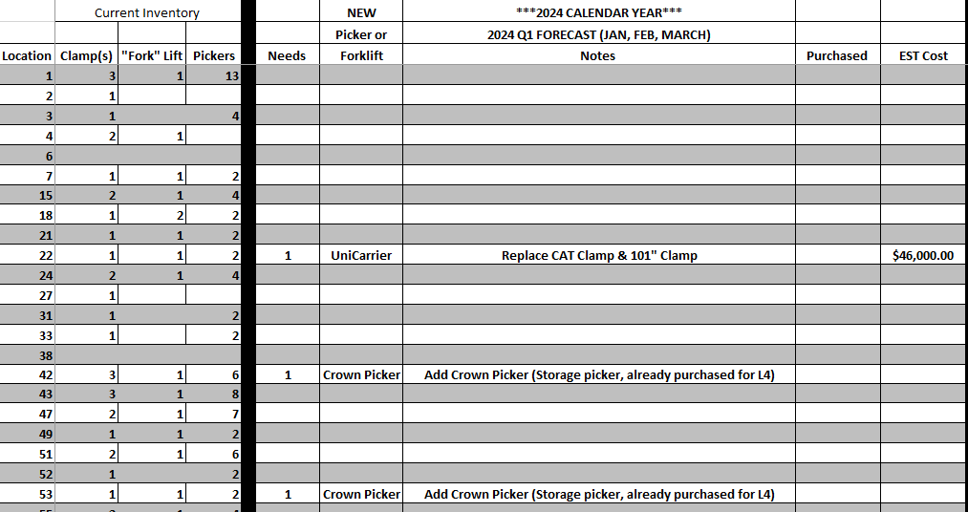

- Once the forecast has been completed, it needs to be sent over to the Managing Director – Projects for approval.
- At this point you’ll know what you need for next year. Reach out to our contacts on pricing and availability. (North Coast, Lift Solutions, Crown). Their information is in section 4.
- Orders could take 6-8 months to come in. Once you have the prices and ETA, send them up to Managing Director- Projects for approval.
- Send proposal to K&M President.

Forklift Summary Spreadsheet
A summary spreadsheet is on the F: Drive that breaks down all forklifts per location, make, model, ID Number, date of purchase, purchase drive and where we purchased life from. This spreadsheet is updated by the Fleet Acquisition Manager anytime a new purchase is made, we sell off a forklift, or move a forklift from one warehouse to another.
F:\Logistics\Public\Trucks & Trailers\Trucks & Trailers.xlsx

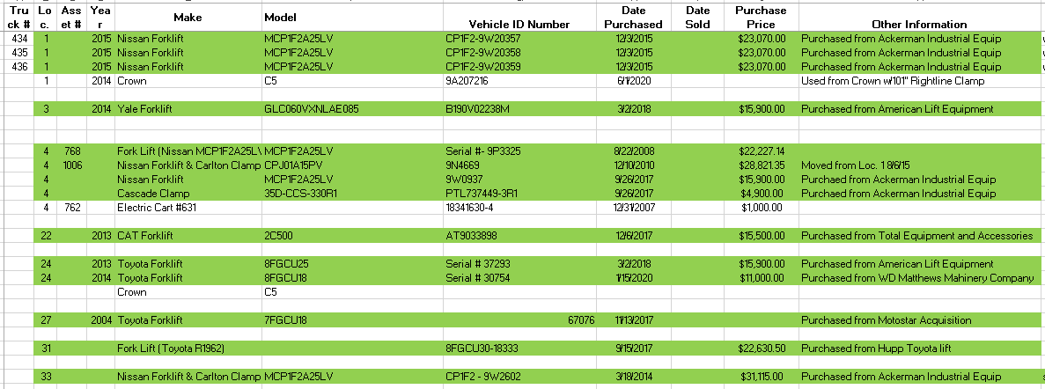

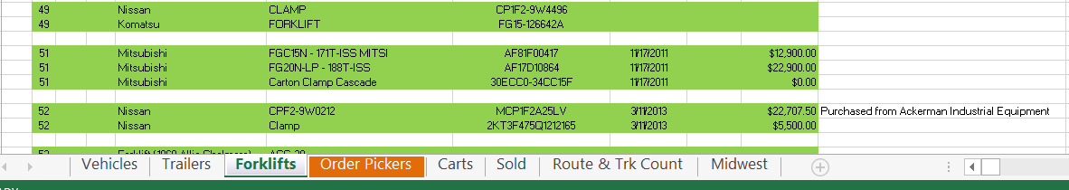

Forklift Dealers for Quotes
These two Forklift brands that have performed well for K&M Tire over time are Nissan/Unicarrier and Crown.
- Lift Solutions Inc.
  - Nissan/Unicarrier Lifts
  - Cascade Clamp Attachments
- Crown Equipment
  - Crown Lifts
  - Rightline Clamps 77” & 101”
  - Opensings
  - Cascade Clamps Attachments
  - Contact Information:
    - Greg Ahrns – Gregory.ahrns@crown.com
        - Phone number – Office 937-454-7545 or Cell 419-305-5565
    - Brian Haynes – bhaynes@lsi.bz
        - Phone Number – Office 316-262-1426 or Cell 316-650-7361

Forklift Purchase Approval Summary
All new forklift purchases must be approved by President. When writing a summary on a new forklift purchase proposal, the key is to be as detailed as possible and make sure you’re stating all the facts. Make sure all questions are answered in your email, be as detailed as possible. Include any spreadsheets or documents that have more information as to “why” you are requesting to purchase a new forklift. In the closing or bottom of the email is where to use “bullet points” as to what the Fleet Acquisition Manager proposal or thoughts are on the subject.

NEED EMAIL EXAMPLE WITH CORRECT AMOUNT OF DETAILS.

Forklift Purchase Approval Summary
To help control the cost of Forklift & Picker Maintenance, The Warehouse Managers will email a copy of the repair estimate and parts breakdown to the Fleet Maintenance Manager for any repair estimates over $1500.00. The Fleet Maintenance Manager will review the estimate and pricing and send back an approval or denial email to the Warehouse Manager.
There are a few reasons why it is important for the Fleet Maintenance Manager to review these higher repair costs on our forklifts and pickers trucks. The Fleet Maintenance Manager can determine if it is time to replace instead of fixing, The Fleet Maintenance Manager can verify shop pricing on parts and labor, he can verify warranty on any past work performed on truck or ask the Picker or Forklift dealer rep if they will help cover the repairs.
Example:
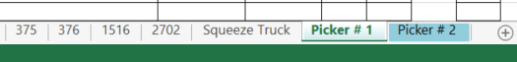

Having the correct hours on unit, date of service and detailed description is key when the forklift or picker has to have future work performed. This information helps the Fleet Manager get items covered under warranty or cost passed on to Vendor for payment. Items correctly entered in Maintenance Log also helps with replacement and when K&M Tire should retire or replace any of our forklifts or pickers.

Transporting Clamp Trucks at K&M Tire
The purpose of this procedure is the safe transportation of any of our clamp trucks from warehouse to warehouse.

Approval & Notifications
- Approval from ROM, Director or VP of Operations.
  - This approval ensures that transportation is necessary and timely.

- Niece Transportation and Driver are notified.
  - Once approval is granted, Niece Transportation and the designated driver should be notified of the transportation request. This notification should include the origin and destination warehouses, the approximate time of pick-up, and any other relevant details.

Steps for Preparation/Transportation:
- Clamp a large ag tire
  - Before the clamp truck is driven onto the trailer, a large agricultural tire (e.g., 20.8-38) should be clamped and secured during transportation or large stack of semi-truck tires. This step helps to stabilize the load during transit.
**If there aren’t any larger Ag or stacked semi-truck tires on the final load sheet: please enter a stock transfer for one large Ag tire to the clamp trucks destination location** This will need to be transferred back on the next available transfer.
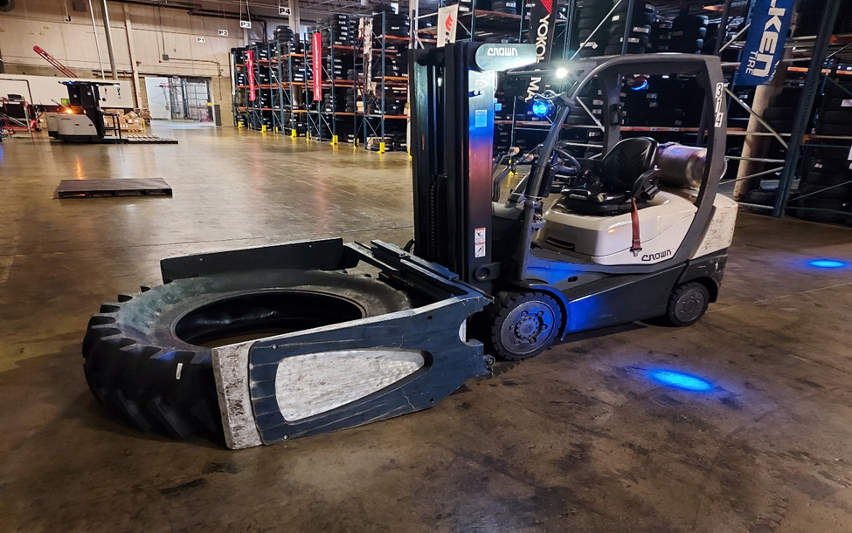
- Drive Clamp onto the trailer.
  - The clamp truck should then be driven onto the trailer, ensuring that it is properly aligned and centered. This step requires a skilled driver who is familiar with the clamp truck's operation.

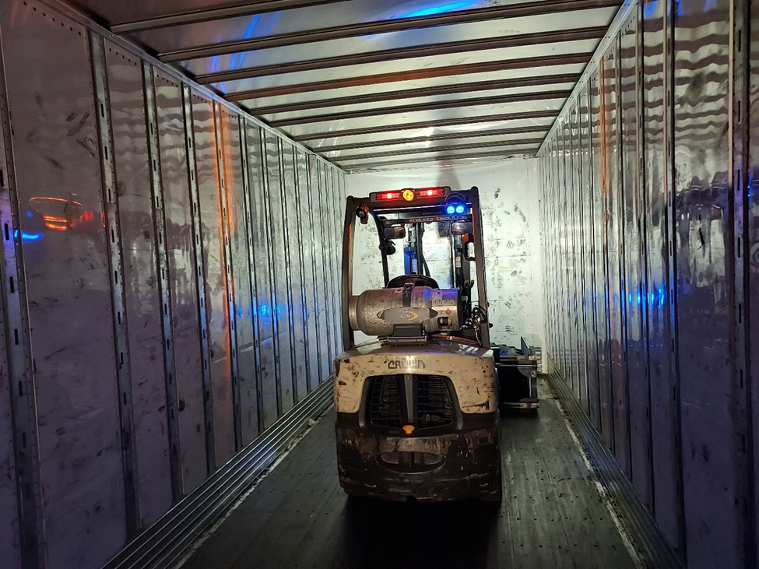
- Lower clamps to the floor while continuing to hold the ag tire.
  - Once the clamp truck is on the trailer, the clamps should be lowered to the floor while continuing to hold the ag tire. This step helps to stabilize the clamp truck and prevent any movement during transportation.
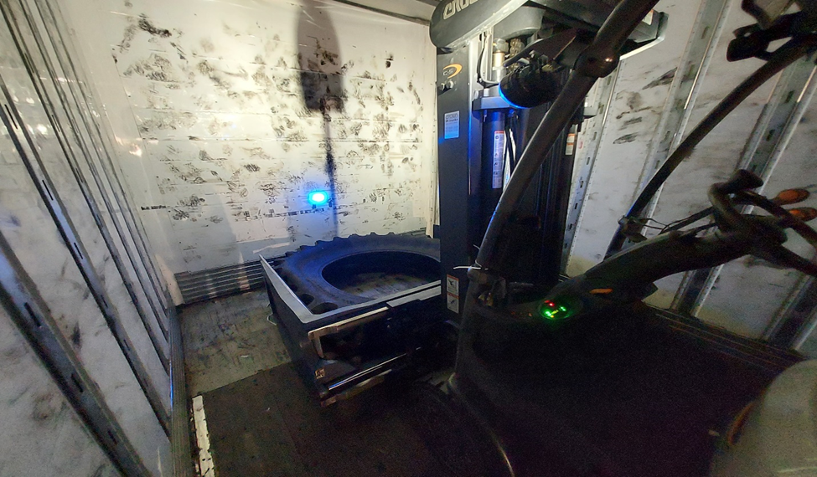
- Turn the fuel supply off and disconnect the propane tank.
  - The fuel supply of the clamp truck should be turned off and the propane tank should be disconnected. This step is crucial for safety reasons, as it prevents any potential fuel leaks or fires during transportation.
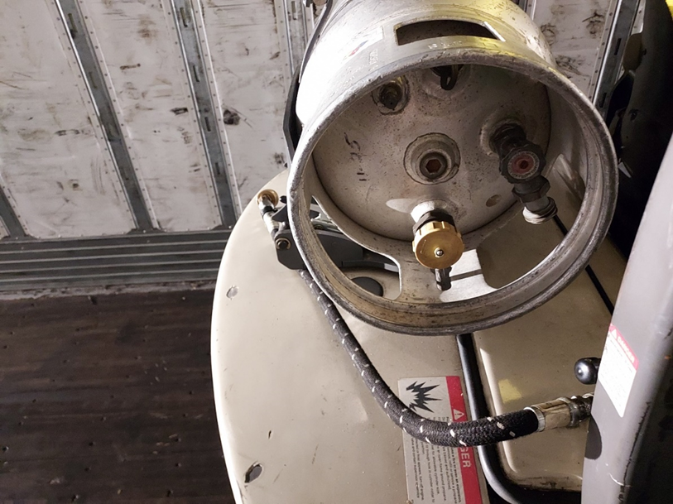
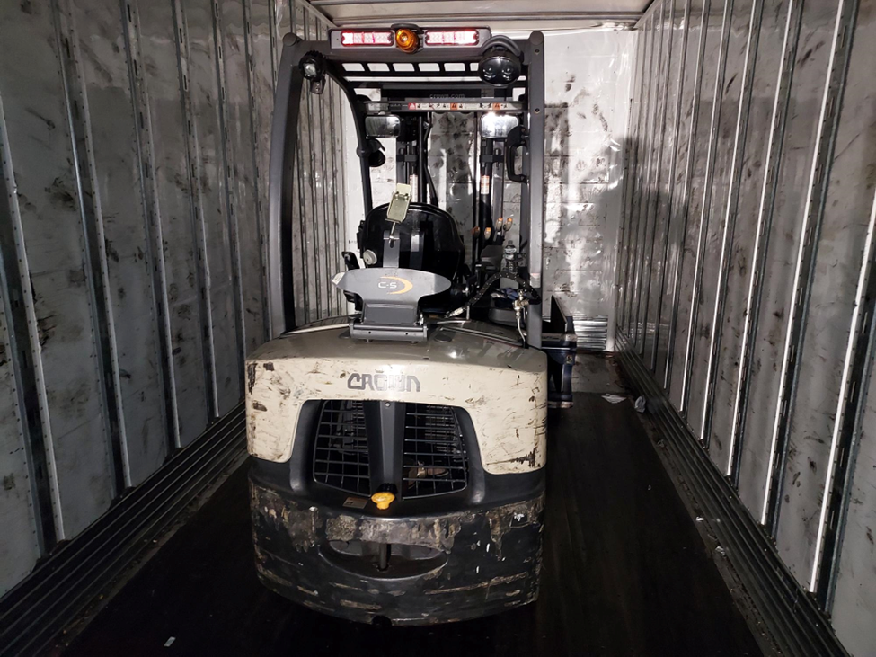

- Chock Tires -
  - Chocking of tires to include using a 2x4 fastened to the floor with screws behind one set of wheels, either front or back wheels. Chocking the tires helps to prevent the clamp truck from moving during loading and unloading.
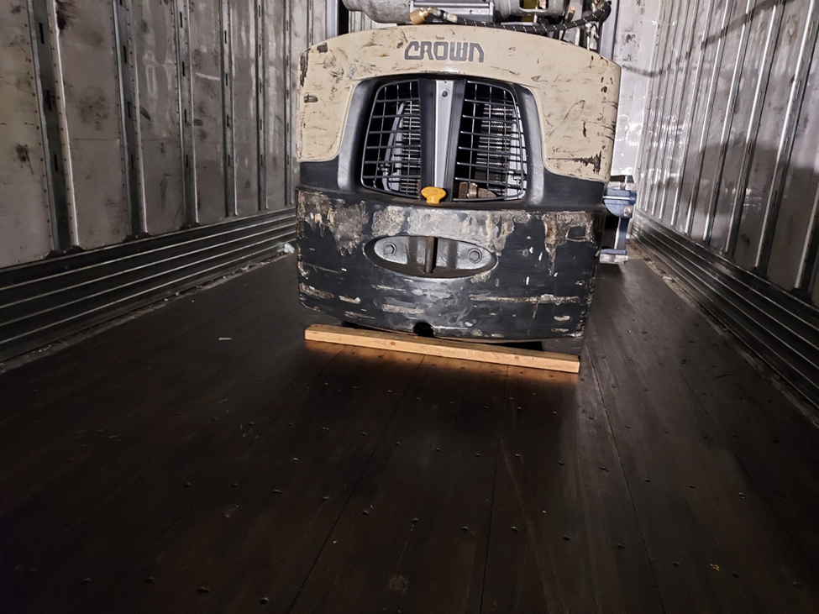
- Strap the Clamp to the wall of the trailer using properly weighted straps.
  - The clamp truck should be strapped to the wall of the trailer using properly weighted straps. This step ensures that the clamp truck is securely fastened during transportation and cannot move, even in the event of sudden braking or swerving.

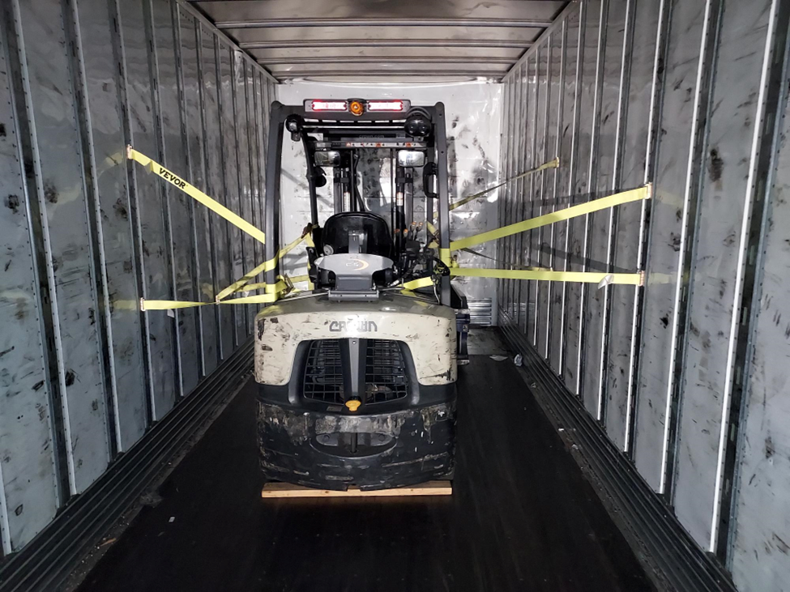

Checklist
Approval from ROM, Director or VP of Operations

Niece Transportation and Driver are notified.

Clamp a large ag tire (ex20.8.38).

Drive Clamp onto the trailer.

Lower clamps to the floor while continuing to hold the ag tire.

Turn the fuel supply off and disconnect the propane tank.

Chock Tires – both front and rear.

Fleet PM Schedule (Manager’s)

Maintenance Schedule
Managers are to follow the PM schedule on forklifts and pickers. Forklifts are to be PM serviced ONCE per year, picker PM do vary per location depending on location, and Hub service is different than satellite locations.

There are a few reasons why it is critical for the Warehouse Manager to follow the maintenance Schedule, the most important one for the forklift and Picker Safety for the operators. Another reason is the longevity of the forklift and picker, being able to get the most hours out of our pickers and forklifts before we replace, giving K&M the best ROI on purchase. Doing regular PM on time also protects the manufacturers’ warranty on the pickers and forklifts.

Picker PM Intervals (HUB Warehouses)
- Pickers PM is 4x per year, every 3 months.
- Battery PM is 2x per year, every 6 months
- Chargers PM is 1x per year.

Picker PM Intervals (Satellite Warehouses)
- Pickers PM is 2x per year, every 6 months.
- Battery PM is 1x per year.
- Chargers PM is 1x per year.

Forklifts PM Intervals
- All forklifts OM is 1x per year.

Maintenance Log (Manager’s)
When ANY service or PM’s are completed on K&M’s Fleet of forklifts and pickers, the Manager must update the Maintenance Log out on the F: Drive with date, hours, repair shop, detailed description of service completed, shop invoice number, cost and initials of who updated the Maintenance Log. The Maintenance Log can be found: F:\Warehouse\Shared\Maintenance Logs
Submit the below to IT for project proposal to add on Intranet.
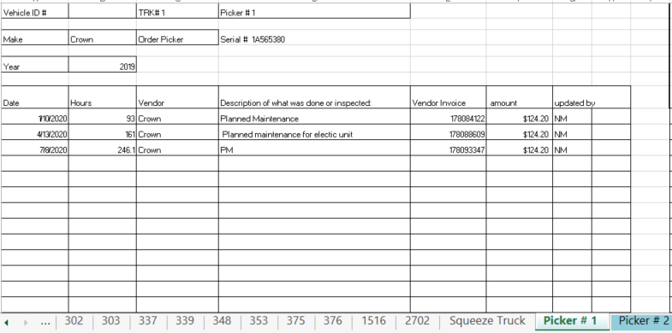
** The Maintenance Log is laid out on the F: Drive for each location has its own log and tabs across the bottom of the Excel sheet for each picker and forklift at that location.

Example:


Having the correct hours on unit, date of service and detailed description is key when the forklift or picker has to have future work performed. This information helps the Fleet Manager get items covered under warranty or cost passed on to Vendor for payment. Items correctly entered in Maintenance Log also helps with replacement and when K&M Tire should retire or replace any of our forklifts or pickers.

Estimate Approval / Denial

Estimate Review
- Open email containing the estimate from repair shop.
- Locate picker / Forklift number and hours on Maintenance Log.
- Open Maintenance Log for that location on F:Drive and locate tab for picker / forklift in for repair.
  - F:\Warehouse\Shared\Maintenance Logs
QUESTIONS:
- Was any previous work done for the same service within 1 year (calendar)?
  - If YES: email manager letting him / her know repairs will be covered under warranty.
- If picker / forklift still covered under manufacturer’s warranty? (see warranty tab)
  - If YES: email manager / shop letting them know repairs will be covered under warranty.
- What is hours of picker / forklift?
- What is the cost of repairs?
- Is picker / forklift worth fixing or need replaced?

Estimate “Approval”
- Once “approval” has been decided an email needs sent to manager stating it is OK to repair picker / forklift per estimate.

Estimate “Denied”
- If estimate is going to be “denied” send an email to President before final decision is made. This email should state what the issues are with picker / forklift, what estimate total id for repairs, hours of picker / forklift.
- Once approval email is back from President it is OK to replace.
- Send an email to manager stating we will not be fixing the picker / forklift the estimate is denied.

Picker Warranty

Manufacturers Pickers Warranty
- Crown
  - Base picker Warranty – 12/months – Unimited Hours
  - Wearable Items – 3 / Months
- Jungheinrich
  - Base Picker Warranty – 12 / Months – 2,000 Hours
  - Powertrain Warranty – 24/ Months – 4,000 Hours
  - Battery Warranty – 60 / Months – 10,000 Hours

Selling Company Assets

When a company owned car/truck/trailer/equipment are no longer needed by the company we will offer these items to employees for purchase. Before a car/truck is to be sold an approval is needed by the: Fleet Manager and Managing Director – Projects.
- Fleet Manager will Identify the value of the car/truck:
- Run value of car/truck on Kelley Blue Book, www.kbb.com
    - Use “trade-in” average value.
- Run value of car/truck on Peddle, www.peddle.com
    - You will receive instant offer, valid for 10 days.
- At time of purchase of NEW car, the VP of Sales will work with the Fleet Manager if the dealership we are purchasing new car from is offering a trade in value. It would then determined by the VP of Sales and Fleet Manger if this trade in value should be accepted or not.

- Once value is determined by Fleet Manager, an email will be sent to Managing Direct – Projects for approval.
- Suggested selling price.
- Year / Make / Model / Miles
- Snip of KBB or Peddle website showing value.
- Any known issues with car/truck.

- When sale price of vehicle is approved the Fleet Manager will move forward with selling the item. Order of Sale will be:

- Once an employee wants to purchase car the employee sends money/check to Fleet Manager, Fleet Manager requests title from Logistics signed by President (K&M Tire/Tribune Trucking). Once money is received Logistics removes asset from Truck/Trailer files and money is turned into Accounting Department. Title is then sent to Purchaser.
***Employees purchasing a vehicle must pay for vehicle in full at time of purchase, no EE loan or payroll deduct is allowed.
***Vehicles are so “as is” and no warranty.

Truck Move Approval

When a new truck purchase happens, the need may arise for a truck move from one warehouse to another warehouse. All truck moves need to be justified and make good business sense. Before a truck is moved approval is needed by: Fleet Manager and Managing Director – Projects.
  - Identifying the need to move a truck -there are multiple reason a truck move may be needed. Below are examples:
- Warehouse needing a truck has high accident rate.
- NEW truck is sent to warehouse with lower accidents, and used truck is moved to warehouse with higher accidents.
- Lack of service provided in area. (No dealerships to service certain brand trucks)
- Drivers not eligible / qualified to drive certain trucks.
- Longevity of NEW trucks at certain warehouses.

  - Once the move is approved by the Managing Director – Projects, the Fleet Manager will:
- Communicate to VP of operations, ROM, the warehouse that the truck will be leaving from, and the warehouse receiving NEW truck and discuss with the Manager of what the plan is.
- Most of the time the warehouse receiving the new truck will have a driver (s) willing to move truck to other warehouse after the new truck is delivered from Dealership.
- Communicate to warehouse receiving the USED truck.
- Communicate to Logistics.
- Order fuel cards.
- Move on Truck/Trailer File.
- Update Samsara

Installing/ Uninstalling Samsara Gateways

Installing

  - Unbox the gateway and cable that was sent to the Warehouse.
  - Connect one end of the provided cable to the diagnostic port in the vehicle, typically located below the steering column, and then connect the other end to the gateway.



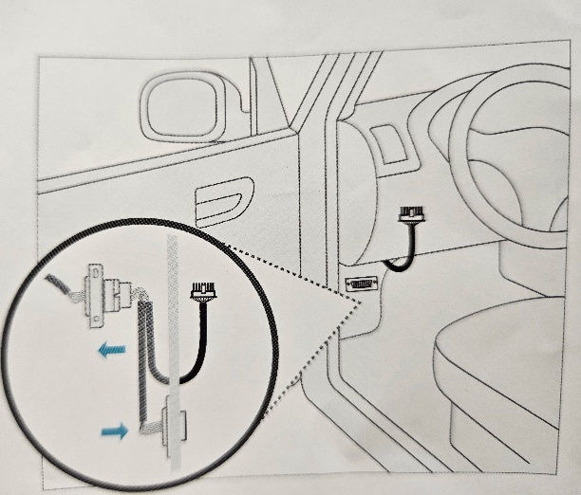

  - Once connected, observe the light on the gateway (Located where the cable connected)
    - Light will flash orange a couple times but then should turn a solid green.
    - If the light continues to flash orange after 20 minutes, then call Logistics.
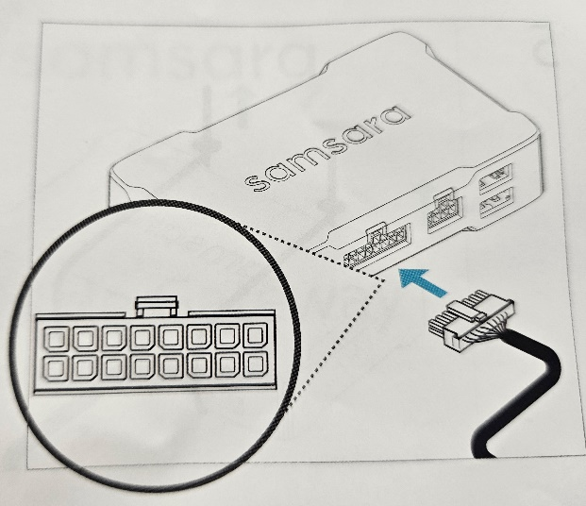

  - Use the zip ties included to secure the gateway and cable under the dash of the truck.

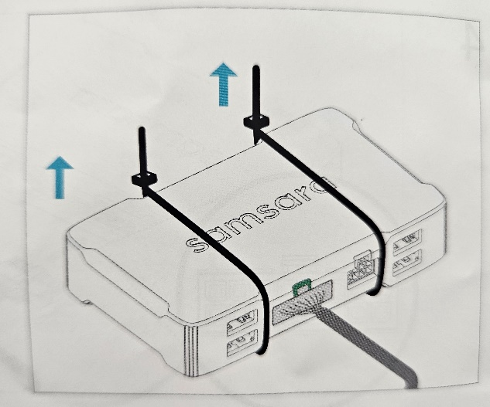

Uninstalling

  - Unplug the Samsara cable from the diagnostic port below the steering column in the truck (Leave the cable connected to the Samsara gateway)
  - Remove any tape, zip ties or anything else that was used to secure the gateway.
  - Send the removed gateway and cable back to Logistics.

Electric Vehicle- Public Charging
The purpose is to explain in detail if it is required to use a public charger. This would be for emergencies only, when the truck needs to use a DC fast charger to get through the day.

ChargePoint- Account Setup

  - Download the app to the route phone that the E-truck will be running. See picture below. That’s what the app looks like in the app store.


  - Once installed, you’ll have to create an account. For the first and last name, use the location name. Example used for Loc. 6.
    - First name: Loc 6
    - Last name: Grandville
    - Email address: That location Manager’s email.
    - Username: The route code the phone is on.
    - Password: Location followed by 0965 (Example…. Loc60965)
    - Postal Code: Warehouse address’s zip code.

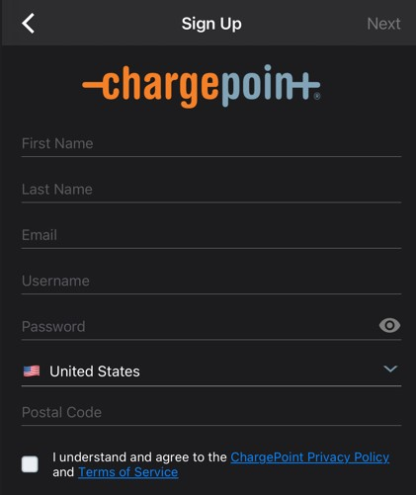

  - It will prompt you to enter your phone number to send a code for verification. Once that’s verified, make sure the box that says “I have a chargepoint home” is unchecked.
  - Next step will be to attach a credit card or type of payment to the app. You should receive a credit card from the Accounts Payable/ Accounting department for this app. Enter that information and save. Now your phone is ready to be able to be scanned at the ChargePoint station.
    - The credit card needs to be kept with the manager and not in the truck. It will be the manager's responsibility to submit that credit card statement monthly in Concur.
  - The ChargePoint app has a map to show you the location and status of chargers available in your area. This will let you know if they are currently being used and where they are located.

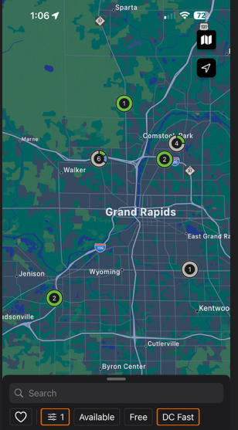

ChargePoint- Charging Instructions

  - See below. This is an example of what the charging station will look like.
  - The station will direct you to provide payment to use for the charge.
  - The first thing you need to do is go into the ChargePoint app on the route phone.
    - Once in the app, take the phone and hold it up to the area arrow is pointed at below. This will beep or notify you on the display that you can proceed with charging.
  - Grab the correct type of charger and plug it into the truck. Once inserted, the display on the ChargePoint charger will let you know charging has begun. It will let you know how much charge has been gained and how much you will be charged.
    - You can disconnect at any time once you feel like the vehicle is at a sufficient charge to finish the route and return to the warehouse.
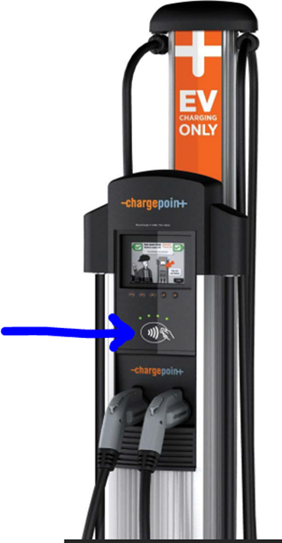

Miscellaneous

Code for padlocks on gates

- Both padlocks will be set to the same code. The code is 0791.
  - To change the code on the lock, you will open the lock, insert the key into the slot on the side of the lock with the lock open, turn the key to the right, set the code, then remove the key. After this the code has been changed. As pictured below.
  - The keys for the locks will be located in the safe with all of the K&M keys that we have. The safe is located in the accounting area in the corporate office.
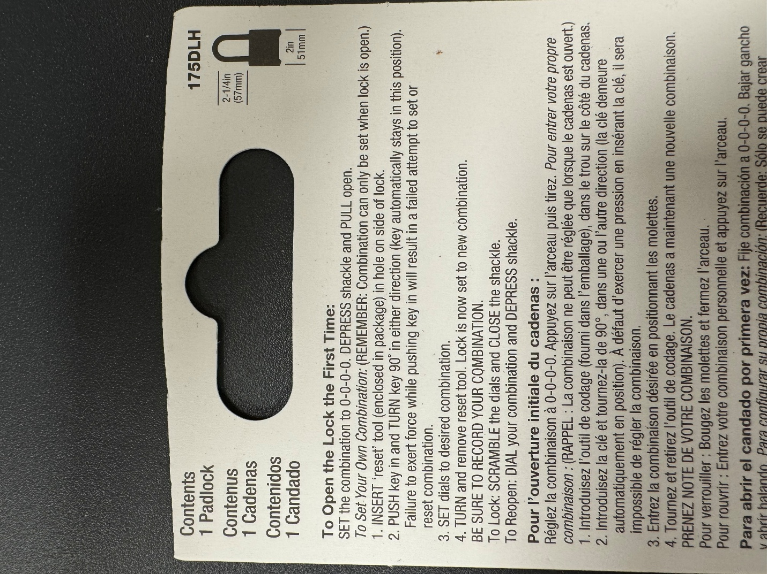
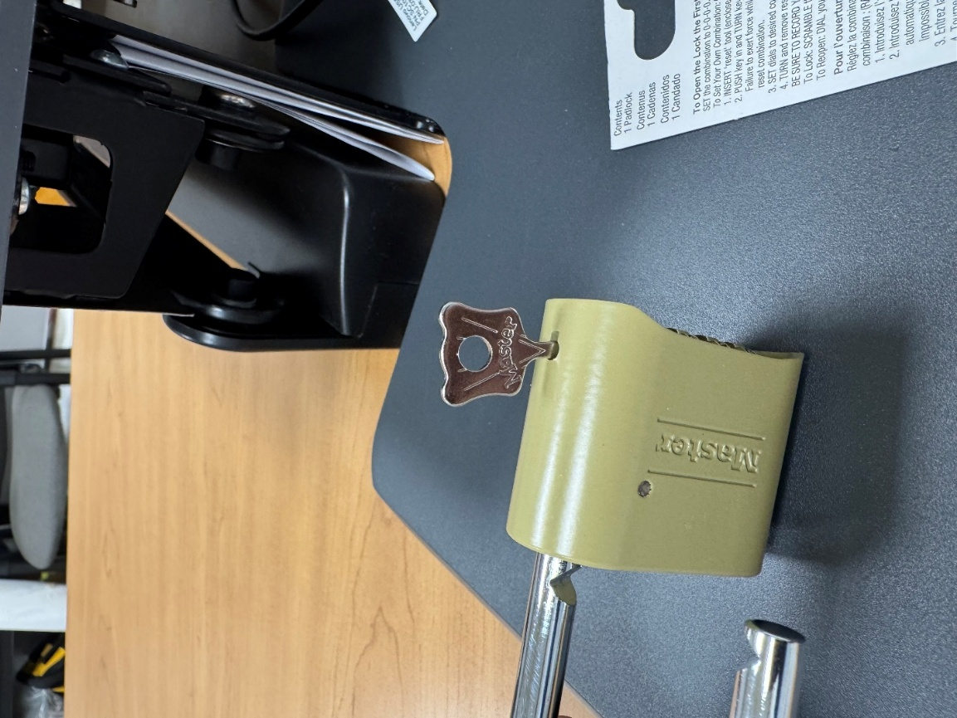
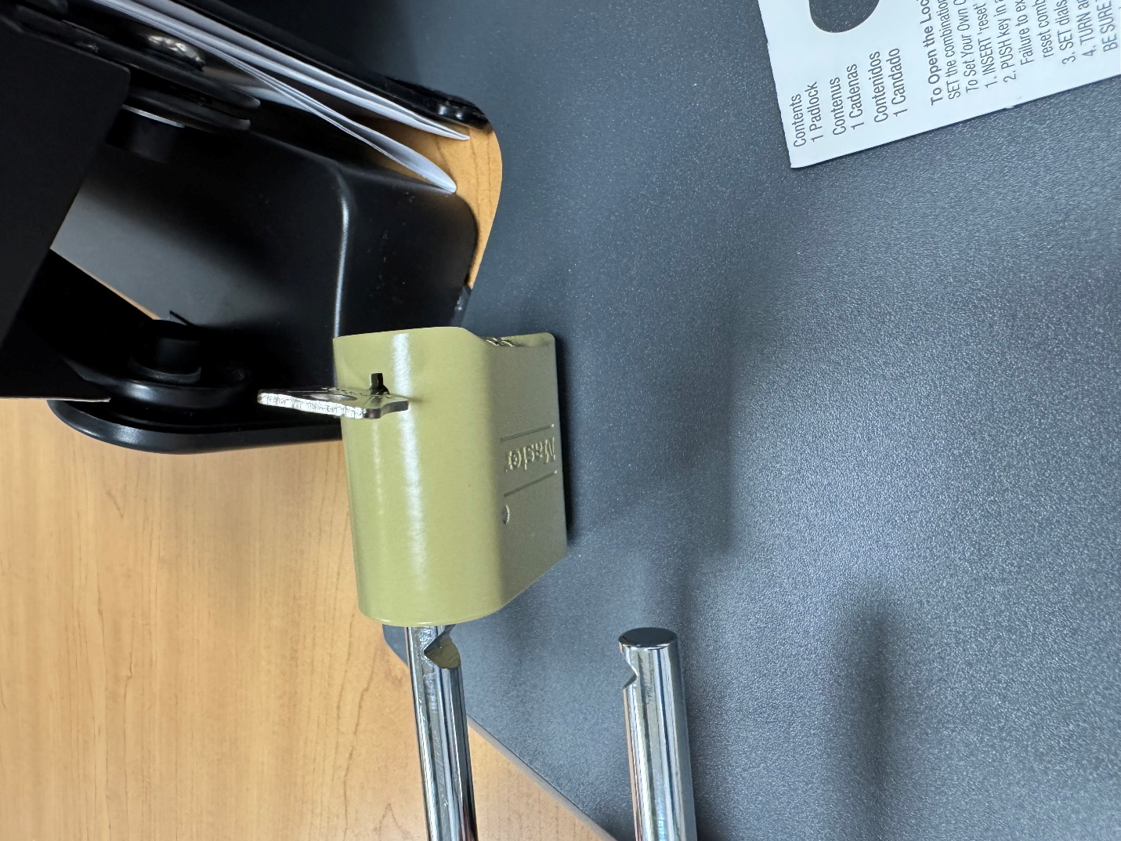

Appendix H: Revision History Tracking
The following table records information regarding changes made to the Operations Binder.

Table 1 - Revision History Tracking
Version Number | Date | Author/Owner | Description of Change
 | 1/6/2023 | Shaina Johnson | Add section 26 & 27
 | 6/21/2023 | Kayla Perrine | Added Sections 3.4 & 5.4
 | 10/6/2023 | Kayla Perrine | Updated Section 2 & 3.3
 | 4/19/2024 | Kayla Perrine | Added 29
 | 1/02/2025 | Barb Suever | Updated Sections 2 through 3.4
 | 1/02/2025 | Barb Suever | Updated titles for 20 & 21
 | 1/03/2025 | Barb Suever | Added Section 8
 | 1/06/2025 | Barb Suever | Added Section 8 - K & M Own Use Tires
 | 02/11/2025 | Barb Suever | Updated Section 19-23 into 19-19.6 Forklifts/Squeeze Clamps
 | 02/13/2025 | Barb Suever | Added SOP for Transporting Clamp Trucks
 | 6/13/2025 | Kayla | Added Codes for padlocks on gates

